**Non-exam assessment A-level Computer Science (7517)**

**Automated Video/Photograph Facial Blurring Tool**

Anton Zhulkovskiy

Candidate Number: 0045

Center Name: Sunmarke School

Center Number: XXXX

Table of Contents

Analysis 4

Project Problem Definition 4

Background to the Problem 4

Interview with head of Marketing at Sunmarke School (Primary research) 5

Observation of Existing Systems (Secondary Research) 6

Current System flowchart 8

Limitations to current systems (Secondary Research) 9

Objectives for the Proposed System 11

Potential Solutions and Justification for the Chosen Solutions: 13

Document Design 15

IOPS Chart 15

Flowchart of proposed system 16

Flowchart of Blurring algorithm 18

Data Dictionary and Validation 19

User Interface Design: 21

Database Normalization and design 29

OOP Class design, variables and data structure definition 32

File Structure and Organization: 35

Algorithm design: 36

Security and Integrity of Data 39

Technical solution: 40

Class and Function definition with data types and programming skills used: 40

MAIN PROGRAM FaceBlurTool.py 43

Face Detecting and Blurring algorithm facebluralg.py 59

MATLAB blurring Algorithm gaussianblur.m 63

SQLite3 Database program database.py 64

Hashing algorithm using SHA256 hashalg.py 69

Testing: 74

Full test video on youtube link and qr code: 74

User registration testing: 74

User Login testing: 78

Hash algorithm testing 80

Blurring images and videos test 82

Database data storing testing 88

Evaluation: 90

Objective table: 90

User Feedback and testing google form responses 92

Conclusive thoughts: 95

# **Analysis**

## **Project Problem Definition**

Client: Sunmarke School Marketing department

Contact: Munmun Lamba,

[m.lamba@fortes.co](mailto:m.lamba@fortes.co),

+971 44471448,

Sunmarke School,

Jumeirah Village Triangle,

Dubai, UAE

## **Background to the Problem**

In the United Arab Emirates recordings in public areas which are later shared online through social media and live television require all unpermitted identities to be hidden as it is illegal to show a person’s face without their permission and could result in large fines or even jail time. The solution most Youtubers, Marketing teams, celebrities and news companies have is manually blurring the faces using typical video editing software.

The current solution that the Sunmarke Marketing department has that prevents them from invading a person’s privacy is to only publicize photos and videos from planned photoshoots with permission from all people in the video. Any unplanned recordings or photos taken by the department requires the editing team to manually blur out faces of people who did not give their permission to be recorded.

## **Interview with head of Marketing at Sunmarke School (Primary research)**

Q: What do you know about the UAE’s regulations in regards to invading a person’s privacy without their permission?

A: As we are working in the marketing department, we have to always make sure that our team is up to date with any laws regarding privacy when filming or taking photos. I am aware that it is illegal to record a person without their permission and doing so would lead to huge fines.

Q: How does Sunmarke currently avoid invading privacy when creating social media posts and advertisements?

A: We usually chose to film advertisements inside the school or in areas with no people other than the ones taking part in the creation of the video or photoshoot. Although for our social media posts we email the parents of students to get permission for their children to get posted or just blur out the faces of people who did not provide their permission to be recorded.

Q: Is there any particular software that is used to blur out faces of people who did not give permission to be recorded or photographed?

A: Our editing team uses Photoshop for blurring the faces in images and for videos they either use YouTube Studio’s tool or an external tool for Premier Pro.

Q: Would you be interested in a program which could automatically blur out faces that are visible in videos and photos?

A: That could potentially save time for the editors but I would first like to see it as it will have to work accurately to prevent Sunmarke online publications from breaking any laws here in the UAE. Apart from that a tool which could shorten our blurring process would be very helpful.

Q: On average how long are the video advertisements or publications in Sunmarke?

A: The video publications are usually no longer than 30 seconds.

Q: What form are most of your advertisements/social media publications in? Photographs or Videos?

A: Sunmarke posts a mixture of videos and photographs so I would say that it is probably quite equally distributed.

## **Observation of Existing Systems (Secondary Research)**

I started by researching existing methods of blurring faces on videos before uploading them to social media. The Sunmarke Marketing department have told me that they make use of a facial blurring tool available in YouTube Studio Editor for videos and manually blur pixels on photoshop for pictures.

YouTube blurring tool process:

* Import your video into YouTube Editor.
* Select automatic facial blurring or manually blur objects.
* If manual blurring selected, using blur tool, blur out required areas on video and choose the duration of the blurring.
* Finally, video is rendered with blurring effects added to it.

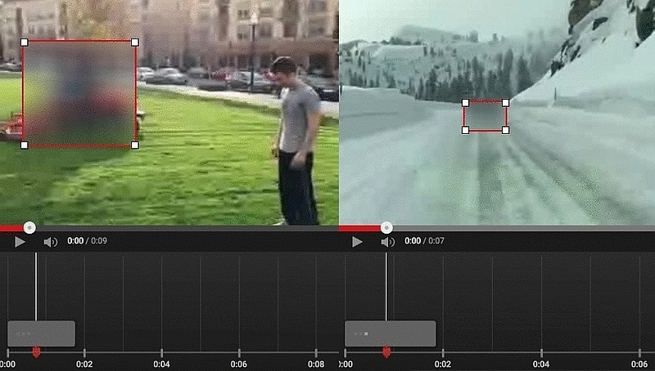

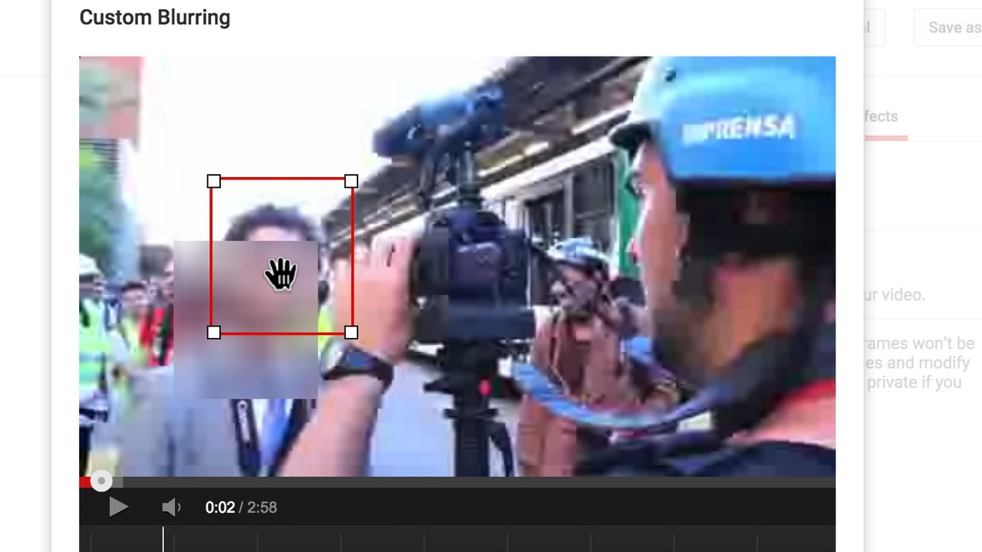

Photoshop blurring tool process:

* On Photoshop use the selection tool to select faces one-by-one
* Open up the filter menu > select blur > select Gaussian blur
* 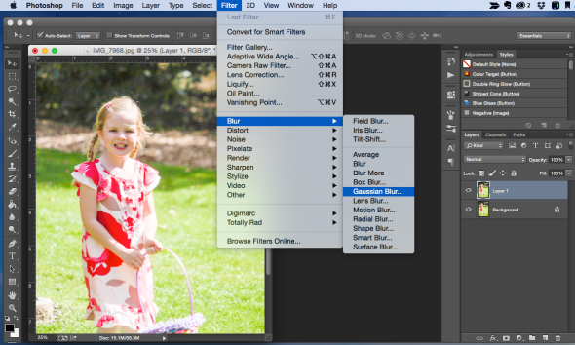Select the intensity of the blur
* Result of the Gaussian blur on photoshop would look like this

## **Current System flowchart**

This flow chart represents the process videos and photographs go through in the Sunmarke marketing department to apply blurring effects. This flowchart will allow me to find ways to shorten/simplify the process and make sure my solution does not have the inefficiencies the current system shows.

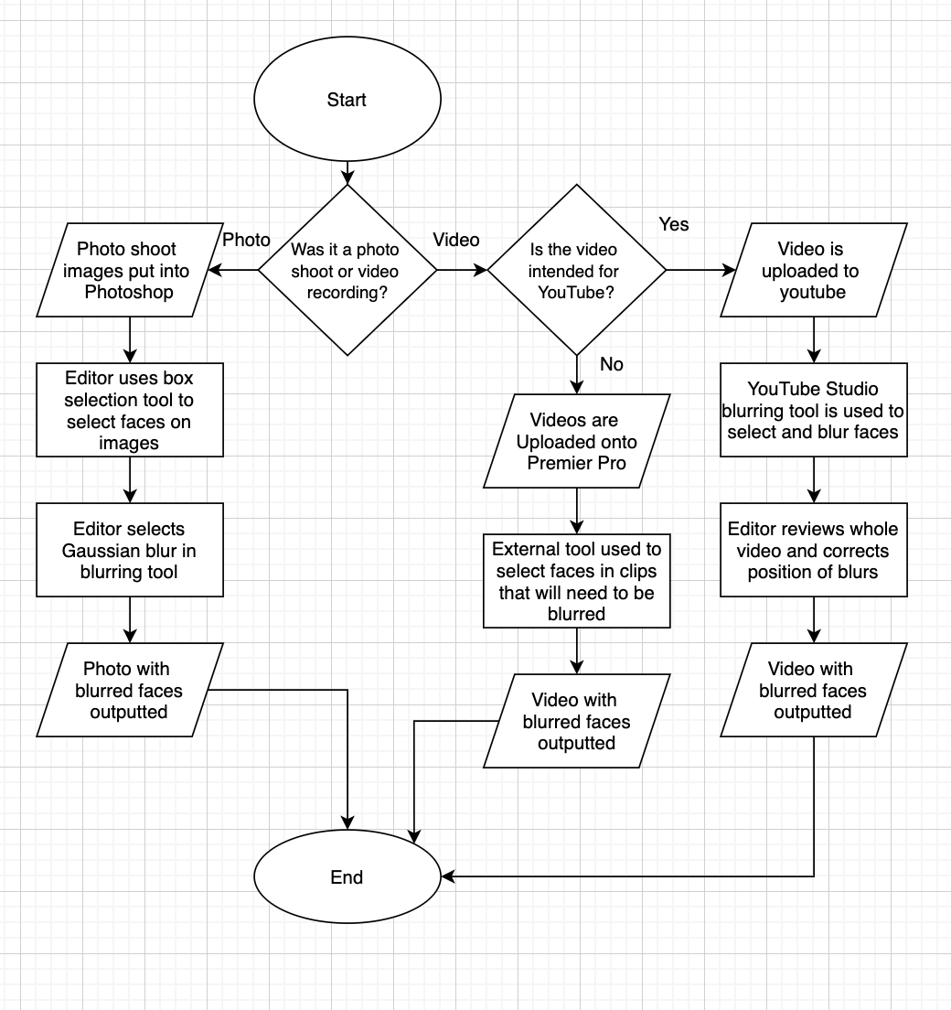

## **Limitations to current systems (Secondary Research)**

As the flowchart shows the current system splits the process of blurring faces into 3 parts depending on whether the product is an image or video and on where the product will be uploaded. For YouTube videos, YouTube Studio’s blurring tool is used, for photographs Photoshop is used and for other videos an external tool in Premier Pro is used.

Overall limitations:

* Different software being used for YouTube videos and other videos as well as photographs.
* More people take part in the process as each editor specializes in their own software

Photoshop limitations:

* Requires editor to select faces one by one. Some tools allow for quick selections but this may result in the blurring of more than just the face.

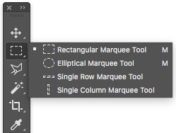

Premier Pro limitations:

* External tool required to be downloaded and set-up for blurring faces
* Inaccurate automated blurring, movement in videos often causes face to be visible
* Requires manual adjustment frame by frame of video
* Process is time consuming as editor has to check each frame for blurring accuracy

YouTube Studio Limitations:

* Most easy to use and accurate software but sometimes has errors in automatic face tracking requiring adjustments
* Only large downside is that the tool is only compatible for videos that are uploaded to YouTube.

## **Objectives for the Proposed System**

For the past couple of weeks, I have conducted primary and secondary research into previously existing systems for blurring faces in videos and images. I was able to identify which features work well in different software and the drawbacks of the types of software when it comes to blurring faces and tracking faces for a moving blur.

1. The system has to have two sections:
   1. Photographs
   2. Videos
2. A system has to be set in place for user to Input their photograph or video
3. User should be able to input pictures of faces they would like avoided in the blurring process
4. System must be put into place to adjust the strength of the blur.
5. Input section has to work quickly and has to be simple to understand
6. Every face in video/photo has to be blurred (except the inputted faces)
7. For videos, blurring has to be done frame by frame for accurate facial tracking
8. Photo blurring process should be almost instant
9. Video blurring process should be quick
10. The user should be given a preview of what the blurred video/photo will look like
11. User should be able to decide whether they are happy with the blur
12. If not, blurring process has to be restarted
13. Once successful, video or photograph should be saved
14. Output should be of the same file type as the user has inputted
15. System must make it clear to user where final file will be saved, or user must be given the option of choosing file location.
16. Login system must be put into place for users to use their preferred blurring settings as well as access their saved faces
17. Fully normalized database should be created to store saved photographs of faces if user choses to save them user login details should also be stored
18. User login details have to be stored encrypted or hashed.

## **Potential Solutions and Justification for the Chosen Solutions:**

1. A desktop blurring tool for photographs and videos. The tool would blur everyone face in the photograph apart from the face closest to the middle on the picture of frame. The tool would have the option for a video or photo to be inputted and corresponding algorithm will be run. Output will be to same video or photo with all but central face blurred.
   1. Would be most suitable for timeframe for the non-exam assessment but is likely to be rejected by Sunmarke marketing team.
   2. Low feasibility only useful for videos and photos with one target person
   3. Would require previous system to be used for videos or photos with more than one target person
   4. Would not work if target persons face is not closest to the center
   5. Would make little to no difference in steps from previous system in most cases
   6. Would not be a worthy system for the marketing team to support my effort
2. An application which can be used to blur faces whilst record the videos or taking the pictures. This would require to be implemented into a smartphone application to be suitable for recording, the app would have options of who to blur in the scene.
   1. Would be able to achieve the final goal of blurring faces of everyone but targets
   2. Would eliminate the previously required systems (photoshop, YouTube Studio and Premier Pro)
   3. Would require Sunmarke Marketing team to use mobile devices when they require faces to be blurred which is inconvenient and can result in lower quality photos and videos. Currently they use professional cameras.
   4. Errors in the system would require videos and photographs to be retaken which could make the system more time consuming than the current one.
   5. May be difficult to create a mobile app in the given time frame as interface has to be modified for different devices.
   6. Would be an improvement from the previous solution if errors do not occur system will be able to record multiple people.

Chosen solution:

1. A desktop blurring tool for both photographs and videos. The tool would take user input of the video/photograph and photographs of multiple angles of the faces of target people in the videos/photographs. The tool would then blur all faces but the ones which were set as target people’s faces. The tool will have a preview of the result and then the photograph or video will be saved to the device with blurring affects applied.
   1. As long as all targets are achievable with my knowledge and research ability as well as in the given time frame this solution has feasibility.
   2. Solution will meet Sunmarke Marketing department requirement of accuracy as the preview tool would allow for user to ensure no faces are visible as well as rerun the tool if failed to meet requirement
   3. Would allow for professional camera use as blurring effects are applied to recorded videos and photographs solving main issue of previous solution
   4. Would get rid of many steps in current blurring system used by Sunmarke Marketing team
   5. Would not require any other software for blurring the photos or videos.
   6. Would not have any effect on requirements for photoshoots or video recordings themselves
   7. Would be simple to use, Marketing team editors would not require to be trained to use the software as they would be able to understand how it works in minutes.
   8. Would contain a local login system allowing each different user in the marketing team to be able to save their own faces to be avoided in blurring
   9. Users last used blurring settings will be saved so they do not need to change them every time they login.

# **Document Design**

Data chart outlining the flow of data in the new system that I am planning to create

# **IOPS Chart**

|  |  |
| --- | --- |
| Input   * Username for login * Password for login * If it is a new user, registration input is username, password, and reentered password * Video file to be blurred * Photograph file to be blurred * Photographs of face/s that should be disregarded in blurring effect (4 different angles) | Process   * SHA256 hashing algorithm applied to username and password * Search for faces in image or frames of video * Compares all faces to the face to be ignored * Blurs all other faces * Shows a preview of the video/photo with faces blurred * Once confirmed, outputs video/photo with blurring effects applied |
| Storage   * Store username and password after hashing is applied on the database. * Select video or photograph to be edited in file system * Store edited video/photograph preview in buffer storage file * Output video/photograph with blurring affect applied to user selected file path * Database to store the faces to not blur for the user. | Output   * Video or photograph with blurring effects applied on all faces apart from the disregarded faces |

## **Flowchart of proposed system**

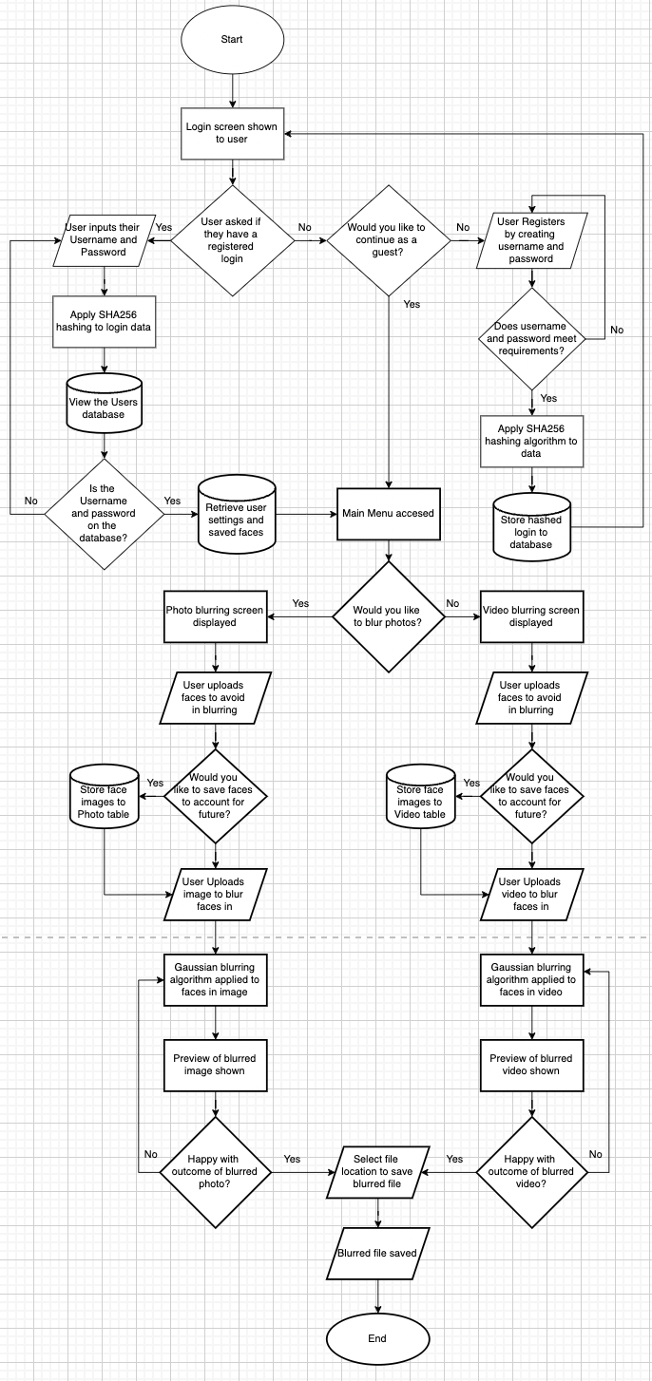This flowchart is a model of the steps required in the process of blurring photos and images using my program. It shows an improvement over the current system through to possibility to save blurring settings, automatically blur all faces in images and videos apart from the uploaded faces.

Continues on next page.



## **Diagram Description automatically generatedDiagram Description automatically generatedFlowchart of Blurring algorithm**

GAUSSIAN BLUR ALGORITHM

MAIN ALGORITHM

## **Data Dictionary and Validation**

The table below shows all the data that users will be inputting and the validation these inputs will be going through.

|  |  |  |  |  |  |  |
| --- | --- | --- | --- | --- | --- | --- |
| Field | Data Type | Length/Size | Validation Check | Validation description | Valid Data | Erroneous Data |
| Create account username | String | 3-15 characters | Character length and ensures username doesn’t already exist. | Checks character length using python variable and len() function. Accesses user database to check if username already exists. | Anton123,  George,  George.m, | EJ,  2, aksjdkasjdlaskfld |
| Create account password | String | Greater than 8 characters | Has to contain capital, lowercase and number as well as correct length | Points system created in program where all types of characters have to be used to allow the password. | Fm123,  F@sldk39,  oLskdi920 | Anton,  1234,  ANSODK,  ansl9 |
| Login, username and password | String | Same as username and password creation | Is username in users database and does password match user | Hashes the value of username and password and compares to hashed values in database users. | Any username and password in database | Incorrect password or username that doesn’t exist in database users. |
| File type selection | Boolean | N/A | Button selected | One of two buttons has to be clicked on | Selects either photo or video option | Does not select option and attempts to continue |
| Video to be blurred | Video | 0-120 seconds, 0-1 gigabytes | File Type | Ensures file type can contain video content | MP4 file or WAV file | Any other file type |
| Photograph for blurring | Image | 0-5 megabytes | File Type | Checks if file type can contain an image | File type must me JPEG or PNG | Any other file type |

## **User Interface Design:**

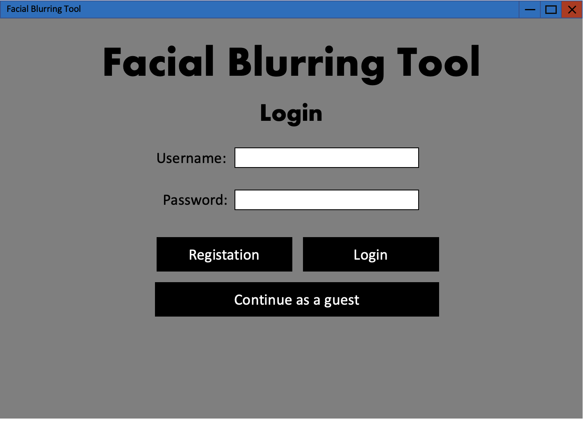

When the program is run a login screen is presented, it will allow the user to login to access their saved face images through a database stopping those faces from being blurred. User can choose to continue as a guest if they do not need to access their saved images.

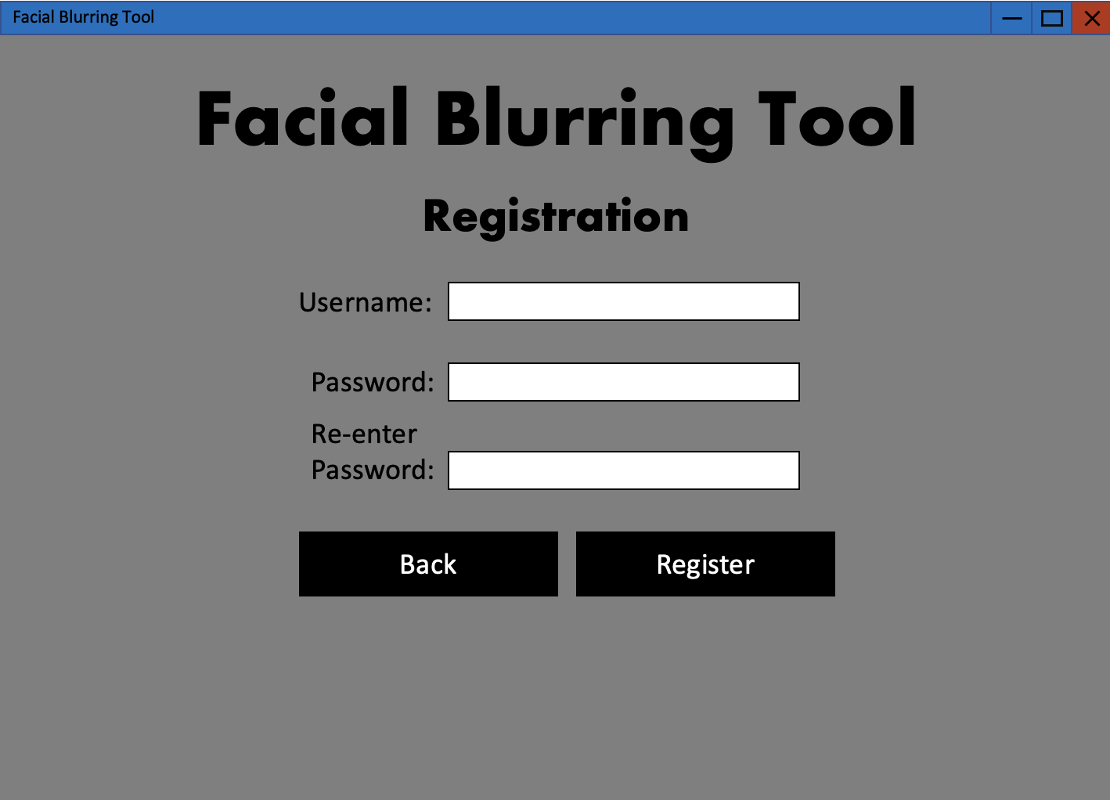

If the users presses the registration button on the login screen, this screen will be shown, user has to input a username and type in the password twice and press register to create an account. By pressing back they will be sent back to the login screen.

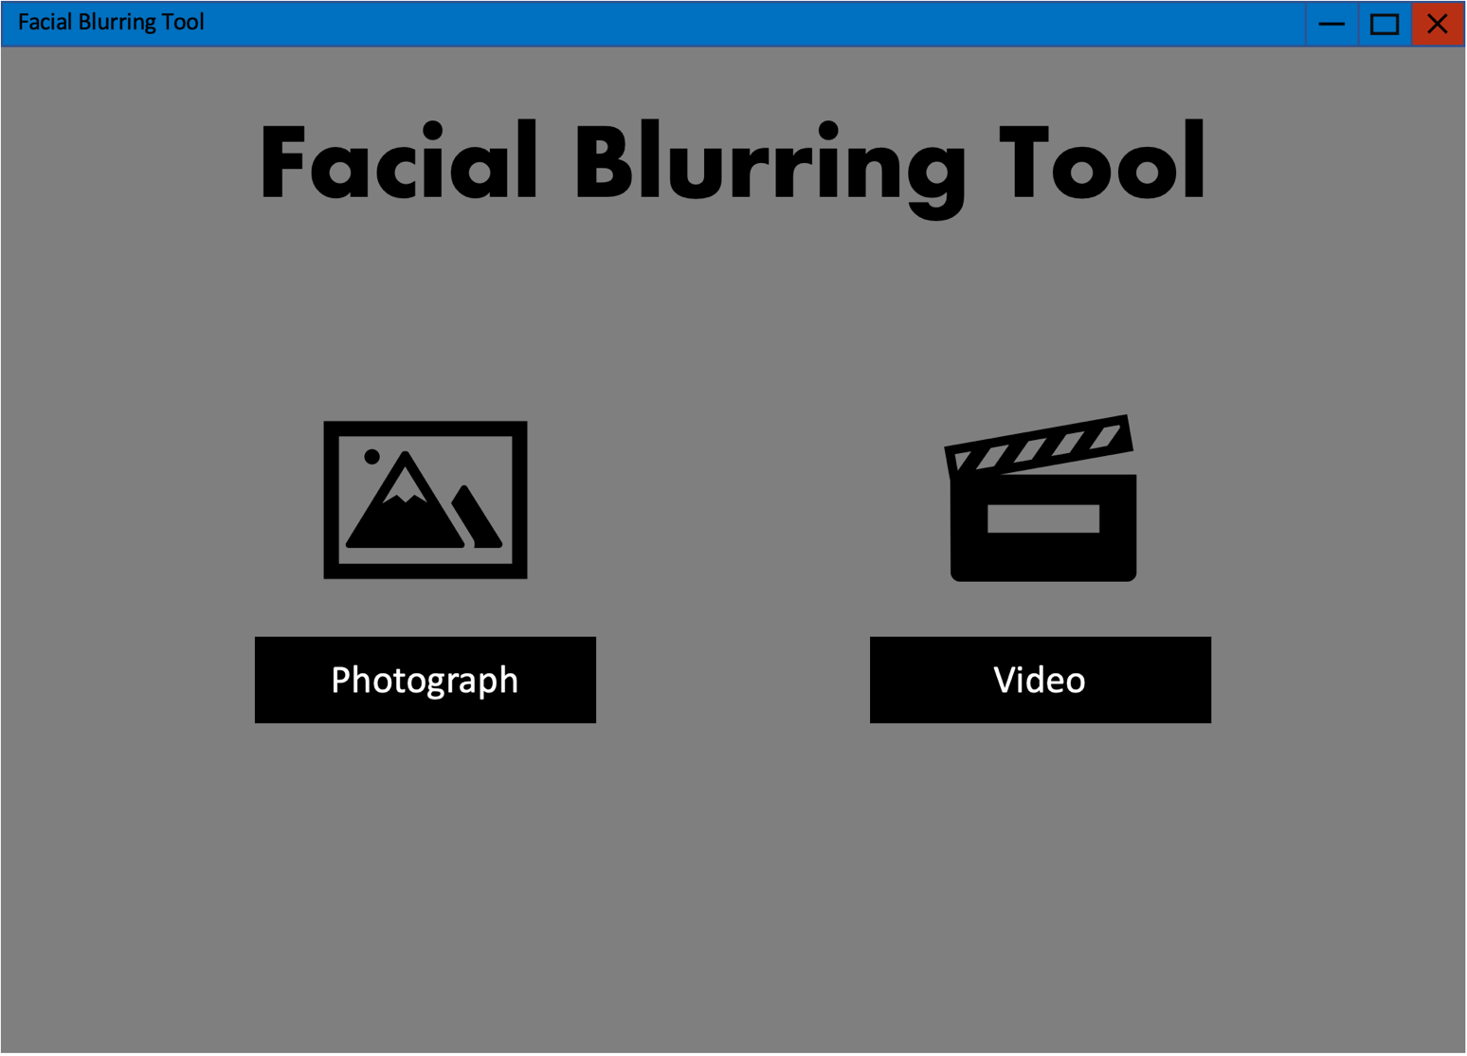

After logging in or continuing as a guest a main menu appears with a title and two buttons: Photograph and Video. The user would pick either video or photograph depending on the file type that they are planning to apply facial blurring to.

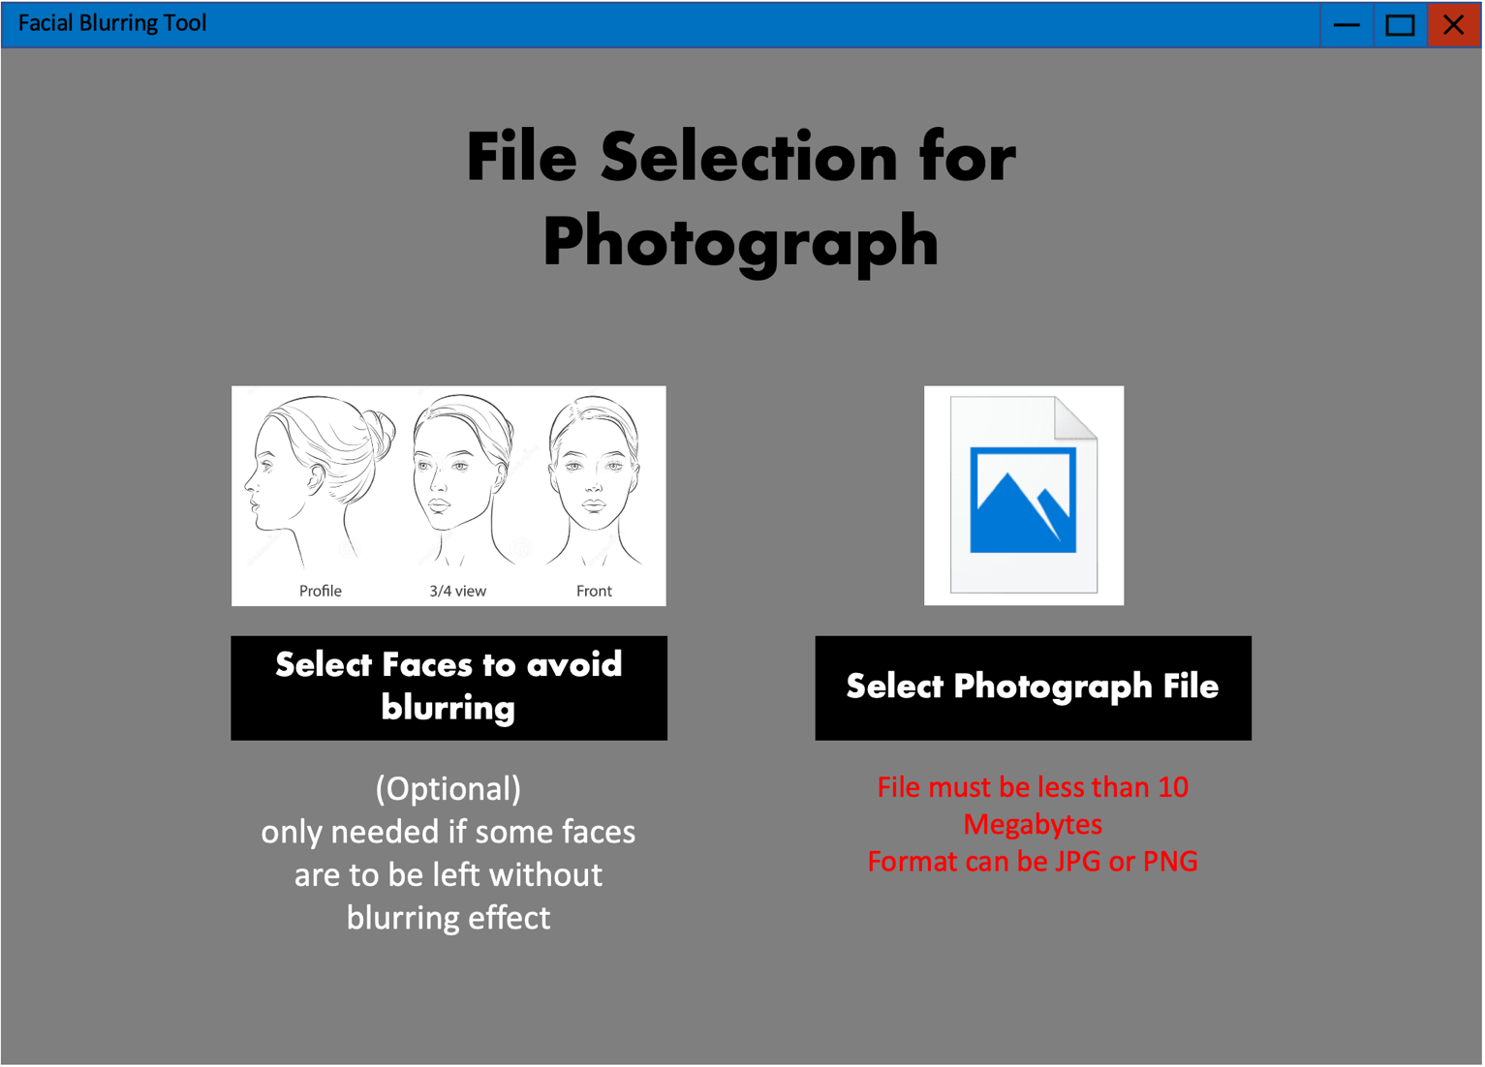

If the photograph button is pressed on the main menu the user will be taken to this screen, they will be given the option of uploading pictures of the face they would not want blurred at all different angles. Also, they will be able to upload the photograph they want the blurring effect applied to.

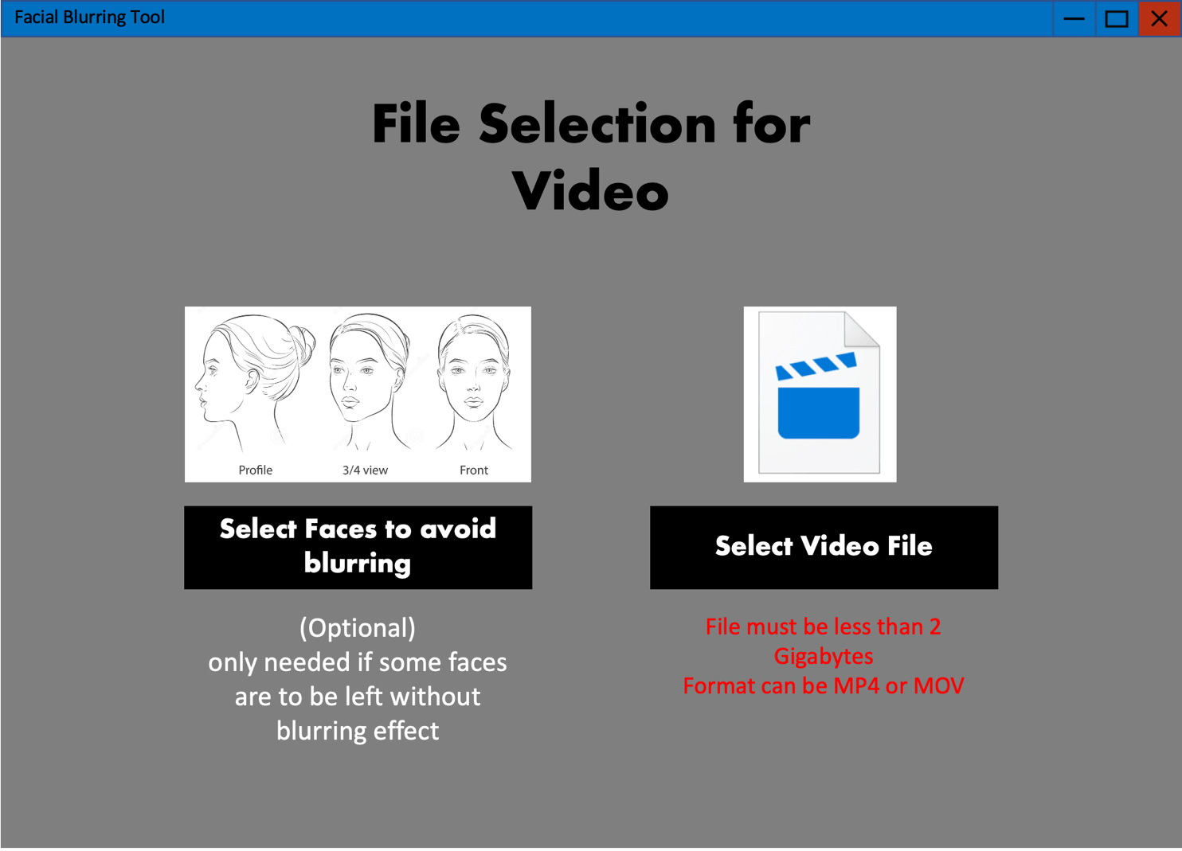

If the Video button is pressed on the main menu the user will be taken to this screen, they will be given the option of uploading pictures of the face they would not want blurred at all different angles, same as the photograph. But, this time the second option is for uploading the video they would like the blurring effect applied to instead of a photograph.

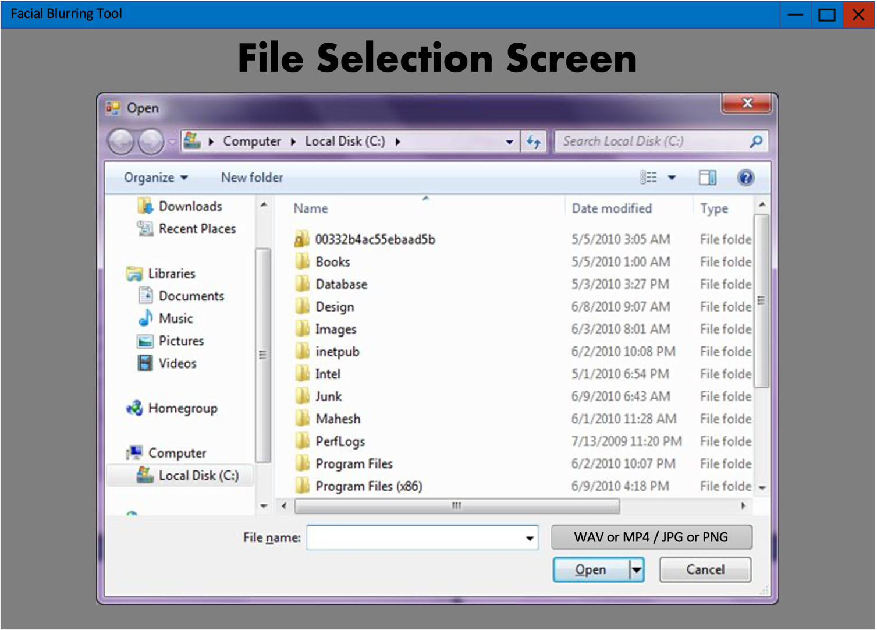

For photographs, videos and faces to avoid blurring buttons, user will be taken to this file selection screen where they can use their file explorer to select the desired file/files. The formats acceptable will be listed and there will be a confirmation if files were recognized as selected successfully.

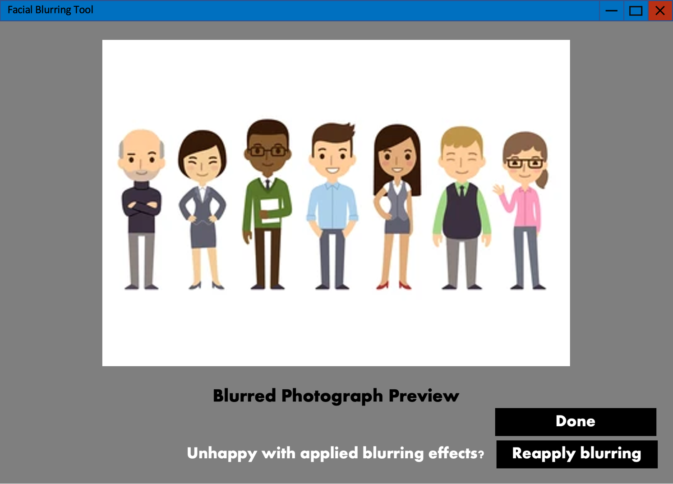

For the photograph option, once files are successfully uploaded, all blurring effects will automatically be applied to the photograph. Once all faces have been blurred, a preview of the photograph will appear on the screen. There will be a done button if the user is happy with blurring effects applied and a reapply button incase the program bugged out and failed to blur some faces in which case blurring will be applied all over again.

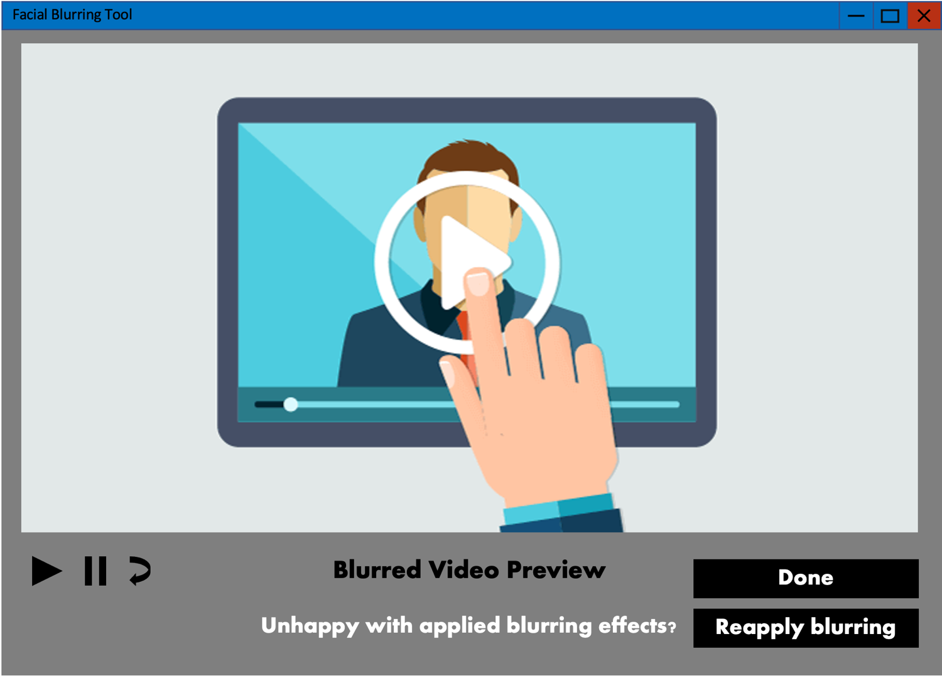

For the video option, once files are successfully uploaded, all blurring effects will automatically be applied to the video. Once all faces have been blurred, a preview of the video will appear on the screen with the option to play, pause and restart the preview. There will be a done button if the user is happy with blurring effects applied and a reapply button incase the program bugged out and failed to blur some faces in which case blurring will be applied all over again.

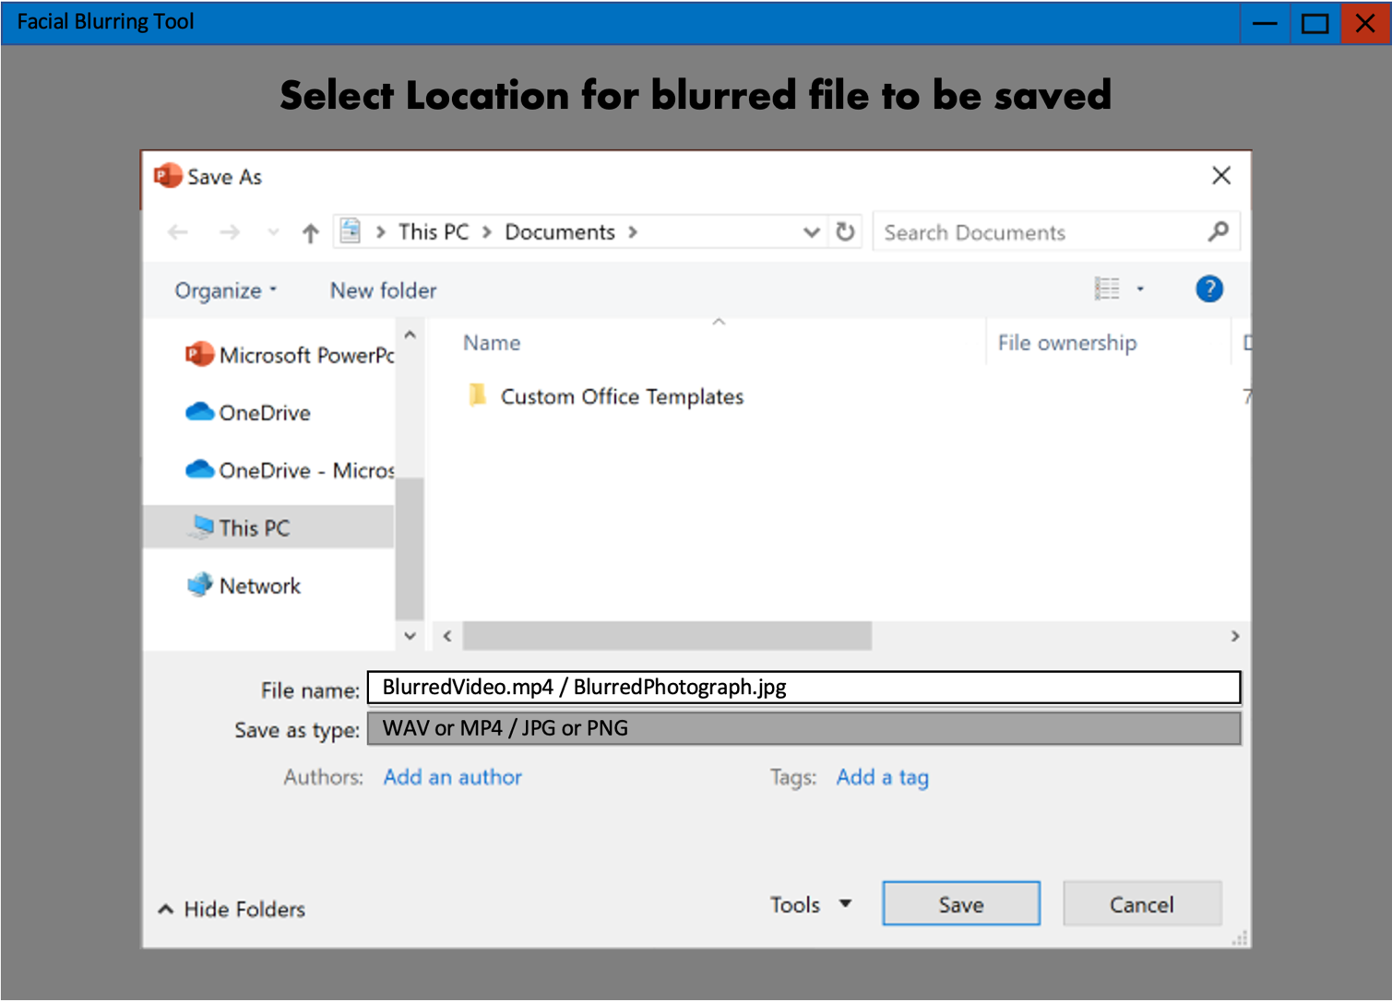

Once done button is pressed, file explorer will be opened again, the user will be prompted to select a location on their computer to store the video/photograph with the blurring effects applied to them. Once save is pressed, the video/photograph will be saved in the same file format as its original form.

## **Database Normalization and design**

|  |  |  |  |  |  |  |
| --- | --- | --- | --- | --- | --- | --- |
| **UserID**(int) | Login (Varchar) | Password (Varchar) | ImageSetting (int) | VideoSetting (int) | PhotoImage (BLOB) | VideoImage (BLOB) |
|  |  |  |  |  |  |  |
|  |  |
|  |  |
|  |  |

This table contains non atomic data in the PhotoImage and VideoImage columns as each user has one userID but may have several face images in both the columns. As a result, these must be moved to new tables and the UserID can be used as a foreign key to access each users face images.

**Bold** means primary key and *italic* mean foreign key.

**tblUsers**

|  |  |  |  |  |
| --- | --- | --- | --- | --- |
| **UserID** (int) | Login (Varchar) | Password (Varchar) | ImageSetting (int) | VideoSetting (int) |
|  |  |  |  |  |

**tblPhoto**

|  |  |  |
| --- | --- | --- |
| **PhotoID** (int) | *UserID* (int) | PhotoImage (BLOB) |
|  |  |  |

**tblVideo**

|  |  |  |
| --- | --- | --- |
| **VideoID** (int) | *UserID* (int) | VideoImage (BLOB) |
|  |  |  |

The table is in third normal form allowing for quick access using the USER_ID. With the User_ID as the foreign key in tblPhoto and tblVideo each user login will allow access to all the images under their User_ID. These Images will be the faces the user has chosen to save on the database for future use so that these faces do not get blurred when the user is logged in.

**Simple database relationship Diagram**

tblUsers (UserID, Login, Password, ImageSetting, VideoSetting)

tblVideo (VideoID, UserID, VideoImage)

tblPhoto (PhotoID, UserID, PhotoImage)

**Possible SQL queries**

|  |
| --- |
| Create table users |
| “CREATE TABLE IF NOT EXISTS tblUsers (UserID INTEGER NOT NULL PRIMARY KEY, username VARCHAR(40), password VARCHAR(40)” |

|  |
| --- |
| Create table images |
| “CREATE TABLE IF NOT EXISTS tblPhoto (PhotoID INTERGER NOT NULL PRIMARY KEY, UserID INTEGER NOT NULL, PhotoImage MEDIUMBLOB NOT NULL, FOREIGN KEY(UserID) REFERENCES Users.UserID)” |

|  |
| --- |
|  |
| “CREATE TABLE IF NOT EXISTS tblVideo (VideoID INTERGER NOT NULL PRIMARY KEY, UserID INTEGER NOT NULL, VideoImages MEDIUMBLOB NOT NULL, FOREIGN KEY(UserID) REFERENCES Users.UserID)” |

|  |
| --- |
| Add user to tblUsers |
| f"INSERT INTO tblUsers(Username, Password, VideoSetting, PhotoSetting)"  VALUES ('{USERNAME}','{PASSWORD}',10, 5)" |

|  |
| --- |
| Add faces to users Images (current user is the ID of the logged in user and binary data is the binary data of the face image) |
| f“INSERT INTO Images (UserID, face)  VALUES ({CurrentUser},{binarydata}) “ |

|  |
| --- |
| Retrieve faces from table images to stop them from being blurred |
| f“SELECT face  FROM Images  WHERE UserID = {CurrentUser}” |

|  |
| --- |
| Delete certain users face images from table Photos or Videos |
| f"DELETE from tblPhoto WHERE UserID = {CurrentUser }" |

## **OOP Class design, variables and data structure definition**

The main program will consist of several object with each object having the attributes to make up all the items in the GUI. The main Object will consist of methods for file handling and bringing each frame (page) of the GUI to the front when the corresponding button is selected.

GUI classes:

|  |
| --- |
| class Blurring (): |
| Faces list (stores file locations of face images to prevent them from blurring)  Main images string (stores the file location of the main image selected by user)  frames tuple (stores all the frames of the tkinter GUI, each frame was shown above in the user interface design section) |

|  |
| --- |
| Class MainMenu(tk.Tk): |
| Contains object for UI as attributes with no methods |

|  |
| --- |
| Class PagePhoto(tk.Frame): |
| Contains object for UI as attributes with no methods |

|  |
| --- |
| Class PageVideo(tk.Frame): |
| Contains object for UI as attributes with no methods |

|  |
| --- |
| Class PhotoPreview(tk.Frame): |
| Contain UI objects as attributes  Method to load blurred image allowing user to preview their final blurred image |

|  |
| --- |
| Class VideoPreview(tk.Frame): |
| Contain UI objects as attributes  Method to load blurred video allowing user to preview their final blurred video |

Face blurring algorithm class and function:

|  |
| --- |
| Class FaceBlurringAlgorithm(): |
| **Facelocatephoto =** Method to locate all faces in the image  **Ignore_face_encodings** = list that contains encodings of faces that should NOT be blurred.  **Face_encodings =** list containing encodings of all the faces that are in the main image  **Pil_image** = Pillow image format to compare image encodings to ignore_face_encodings and get the locations of faces that need to be blurred.  **Blurfaces** = Method to crop out the face from image and calculate the required padding to ensure the gaussian blur algorithm has enough pixels around the face for a smooth blur. Face is then sent to Function I made in MATLAB called gaussianblur.m. |

|  |
| --- |
| MATLAB Function gaussianblur (image_name, blur_strength) (not predefined, MADE BY ME) |
| **I** = converts image to from TrueColor to double precision to allow for matrix manipulation.  **Kernel =** 2-dimensional matrix created to store the weightings of all the x and y positions of pixel in the image calculated using the gaussian function.  **Imar** = converts the double image to an array to split up red, green, and blue values of image.  Temp1, temp2, temp3 = r, g and b values multiplied by the kernel at the pixel position to calculate average r, g and b value of the current pixel to apply blurring  **Out** = converts the imar array with the new (BLURRED) r, g and b values to uint8 to return the face in Jpeg to FaceBlurringAlgorithm() class and paste the blurred face back onto the main image. |

Database class:

|  |
| --- |
| Class Database() |
| Initializes the creation of three interlinked tables in third normal form, **tblUsers** (login and account details), **tblPhoto** (stores users saved faces to ignore in blurring photos) and **tblVideo** (stores users saved faces to ignore in blurring videos).  **UserID** = attribute stores current users ID, if ID stays as 0 then user is a guest  **Find_user** = method to search for user in database by comparing login input to userdata is tblUsers.  **Register_user** = Username has to be unique, username must be 3 characters or longer and not longer than 15 characters. Password strength check algorithm using point system, must contain a capital letter, a lowercase letter, and a number. Password must also be longer then 8 characters long.  **Success_check** = if user registered successfully, sends them back to login screen automatically.  **Video/photo_intensity_get** = method to retrieve the blurring strength last used by the user saved in tblUsers.  **Video/photo_intensity_set =** method to send last used blurring strength to database so it is preset to that strength next time user is logged on.  **Video/photo_insert_image =** method to save face images that user wants ignored in blurring if save checkbox in UI is ticked off. Stores face image as BLOB in tblPhotos or tblVideos depending what blurring the user is currently doing.  **Video/photo_retrieve_image** = method to retrieve users saved face images from tblPhotos or tblVideos (depending on what type of blurring is being used) stores the images in the ignore file to be ignored in blurring process.  **Cleartable** = method to delete all saved faces from database for current user only. |

SHA256 Hashing algorithm class and functions to hash stored username and password for users:

|  |  |
| --- | --- |
| List_and | Logical AND operation by comparing two values at same index of different lists. |
| List_not | Converts all items in the list to opposite value (1 to 0 and 0 to 1) |
| List_xor | Logical exclusive or function on two items at same index of two lists |
| List_double_xor | Logical exclusive or function on three items at same index of three lists |
| List_rotate(k) | Shift items in list by k amount to the right and paste from left side |
| List_shift(k) | Shifts items in list by k inserting zeroes at left side to maintain size of list |
| List_add | Binary addition between two lists discarding any overflowing carryover bits. |

|  |
| --- |
| Class Hashing() |
| **Hex and constants** = constant values used with hash algorithm to hash inputted username and password.  **String_to_binary** = method to store string values of inputted characters as binary in a list  **Bin_to_hex** = method to convert binary list to hexadecimal equivalent.  **Chunker** = method that split list bits into byte chunks and stores in chunk list  **Pad_zeroes** = method to insert zeroes to the bit lists to reach required length, little endian means zeroes are inserted after the existing bits big endian means zeroes are inserted before the existing bits.  **Words_to_32bit** = converts constants and hexes to 32 bit long binaries to use in list operation function I have explained above the Hashing() class.  **SHA256** = method to run SHA256 hash function data to hash inputted values (login or password of user). Makes use a an input, hash function and hash output, which is HASH TABLE type of hashing. |

## **File Structure and Organization:**



**GUI**:

Folder stores all the images and files required for building up the GUI pages for functionality and helping the user understand how to use the application.

**ignore:**

Temporary storage, folder will store images of all users, uploaded faces to avoid in the blurring process. Will also automatically retrieve all saved face images from user’s image table in database faces.bd.

**main**:

Temporary storage, folder for storing the Image file or video file that the blurring will be applied to.

**temp:**

Central folder for the blurring process, will store images of all detected faces in the image, once blurring algorithm is applied blurred face images will be stored here too then pasted onto the main image or video. Once all blurring is applied final file will be stored here until user saves the file or reruns the program. After the program has complete running all items in the temp folder will be cleared for use when program is run again.

**faces.db:**

Database that will store usernames and passwords for each user created. There will be a table to store face images for future use. Users who save their faces will be able to blur images without uploading face images again as the database saved faces will not get blurred again.

## **Algorithm design:**

|  |
| --- |
| **Explanation GUI** |
| Tkinter implementation of frames using a list of different frames to represent each stage in the user interface. Each frame will contain buttons to navigate through the blurring process, text and images will guide the users to understand how to program functions. |
| **Pseudo-code** |
| Frames = [main-menu, video, photo, save]  main-menu.tkraise()  IF VIDEO-BUTTON == 1 then  video.tkraise()  ELIF PHOTO-BUTTON == 1 then  photo.tkraise()  ELIF SAVE-BUTTON == 1 then  save.tkraise()  ELSE:  main-menu.tkraise()  ENDIF  # each page will contain images, buttons and text for user guidance  button = tk.button()  button.place()  image = tk.image()  image.place()  text = tk.bodytext()  text.place() |

|  |
| --- |
| **Explanation facial detection** |
| An algorithm will be put into place to detect faces in the main image and detect faces in the images uploaded to be avoided. These images will be stores in lists, one will contain all the faces in the main image and the other will contain all the faces to avoid in blurring process. These faces are stored as encodings which can be compared to see if faces match up, if they do then the corresponding match will not get blurred. |
| **Pseudo-code** |
| Main-faces=[(face, location-on-image)]  Avoid-faces=[]  For i in (Avoid-faces) do  If i in main-faces do  main-faces(index(i)).pop()  for x in main-faces do  y= blur(x)  paste y on main-image at location-on-image |

|  |
| --- |
| **Explanation blurring algorithm** |
| A mathematical equation will be used to make an algorithm loop through the image traversing through the red, blue and green values of the image to calculate average colour values to apply blurring effect. Each pixel on the face will be given a weighting ensuring that the face structure is maintained even when blur is strong enough to make facial features unidentifiable.  GAUSSIAN FUNCTION IN USE:  A picture containing text, watch, clock, gauge  Description automatically generated  Resultant shape of weightings given to the pixel color averages:  Chart, surface chart  Description automatically generated |
| **Pseudo-code** |
| Function blur (image, intensity)  Read file image im rb  Image = [[[x,y,r,g,b]]]    power = -(x**2 + y**2)/(2*sigma**2) # gaussian equation from above  equation = (e**power)/2*pi*sigma**2  empty_array = empty 2d array size of image  kernel = equation * empty_array # stores weighting of each index calculated using x,y index of array put into equation.  For x in range image width do  For y in range image height do  One =image(x,y,r)* kernel  Two = image(x,y,r)* kernel # find average pixel color  Three = image(x,y,r)* kernel # using kernel weightings  Image[x,y] += [one, two, three]  Paste Image onto main-faces at location-on-image |

|  |
| --- |
| **Explanation of Hashing algorithm** |
| I will be using an SHA256 hashing algorithm which is one of the most used and most secure methods of cryptographic hashing of data. It is part of the secure hash algorithm 2 group which is used by most large companies, websites and databases to create irreversible and unique hashes from data to secure it and prevent users and admins from knowing the data but allowing a function to be used to compare login data and allow user to login with correct credidentials.  The function required 8 predefined hex values and 64 constants which are made by using the the first 32 bits of the fractional parts of the cube roots of the first 64 prime numbers. Then logical operations are such as binary shifts, binary rotates, exclusive OR, AND and NOT are applied to the plain text with the hexes and constants to create a hashed text output which cannot be reversed back to the plain text. When user types in their login data the same hash function is applied to the username and password, if the hashed login data in the database is the same as the hashed login, the user is granted access to their account. |
| **Pseudo-code** |
| hexes = 8 predefined hex values  constansts = 64 predefined hex values  data = input user login/password  binary_list = [binary(data)]  binary_list.append(1)  while length of binary_list not multiple of 512-64 do #64 bits short of  binary_list.append(0) # multiple of 512  length = length of data  binary_list.append((binary(length)) # final 64 bits used to store original  # input string length in binary  32bit_list = binary_list split into 32 bit length for each index  For I in range(48) do  32bit_list.append(32*0)  Binary_rotate.32bit_list[1] by 7  Binary_rotate.32bit_list[1] by 18  Binary_rotate.32bit_list[1] by 3  S0 = 32bit_list[1] XOR 32bit_list[2]  Binary_rotate.32bit_list[14] by 17  Binary_rotate.32bit_list[14] by 19  Binary_rotate.32bit_list[14] by 10  S1 = 32bit_list[14]XOR 32bit_list[15]  32bit_list[16] = s0 + s1 + 32bit_list[0] + 32bit_list[9]  Compression algorithm run on data above using logical XOR with predefined hexes  Final values modified by adding original 8 hexes to 8 indices of compressed hashed binary texts  Hashed_text = Binary_to_hexadecimal(finalvalues) |

## **Security and Integrity of Data**

All the processes in the program will be done locally on the device being used. As the program is being designed for the Sunmarke Marketing team I am expecting that several users will be using shared school devices often. For that reason, I decided that the login data should be hashed to prevent users from seeing each other’s passwords and accessing each other’s accounts and using each other’s saved faces and settings saved in the database. As the hashing algorithm I will be making uses the SHA256 function it will be completely irreversible making the username and password data completely inaccessible even if user decides to investigate the database as no plaintext will be stored, only hashed texts of username and password will be stored. Even an admin who views the program or database will not be able to understand login data meaning users can without fear use their personal passwords without worrying about anyone seeing them.

# **Technical solution:**

## **Class and Function definition with data types and programming skills used:**

|  |
| --- |
| **FaceBlurTool.py (MAIN PROGRAM)** |
| **Objects created:**  **DB =** class database from database.py  **blur =** class FaceBlurAlgorithm from facebluralg.py  **Class BlurringTool(tk.Tk)** object orinentent graphic user interface window.   * Frame = Tkinter frames stored in a tuple initialized with the class * Show_frame = method to bring desired frame to top of window for user to view   **NON GUI methods:**   * avoid_file = method to store users face images in avoid file and depending on user selection also save the images under users unique ID in database. * Main_file = method to store users selected main image in main image file for blurring in the future   **Tk.Frame Classes which are frames created when program is run and brought to front of window using the show_frame function from the BlurringTool Parent class:**  **Class Login -** Frame in GUI for user to input login details  **Class Registration -** Frame in GUI for users to create an account if they don’t have one  **Class MainMenu -** Frame in GUI to show main menu, option to blur photo or video  **Class PageVideo -** Frame in GUI for user to upload video and face images to avoid in blurring  **Class PagePhoto -** Frame in GUI for user to upload photo and face images to avoid in blurring  **Class VideoPreview -** Frame in GUI for user to preview the blurred video before saving or reblurring if not happy with result   * Methods for blurred video to be previewed with functions to skip through the video, play, pause and show drag scale of video.   **Class PhotoPreview -** Frame in GUI for user to preview the blurred photo before saving or reblurring if not happy with result   * Methods to readjust size of image to fit into GUI frame and load the blurred image for user to preview |
| **Skills used:**  **Complex user-defined use of object orientated programming model:**  The GUI uses a parent class which has methods and attributes inherited by each frame class to allow for frames to be brought to top of GUI window. Also, polymorphism, composition and interfaces are used with the blur object and DB objects which uses the blurring Algorithm class and Database class to blur different images and videos as well as handle saved files and SQL queries. Objects are defined by users depending on the buttons pressed in the GUI and the files uploaded by the user and other UI inputs.  **Files organized for direct access:**  2 folders are being used to store image data selected by the user, the images are opened, converted to RGB format, and stored in the avoid file and main file folders for the database program and blurring algorithm program to directly access in their program processes. The face image locations are stored in a list and the list is looped through to write the image data to the avoid folder. |

|  |
| --- |
| **database.py** |
| **Object created:**  Hash_function = class hashing from hashalg.py  **Class Database()** – containing all methods to manipulate database data as well as parameters for creating username and password and logining in.   * **Init** function creates the three tables if they haven’t been created (tblUsers, tblPhoto, tblVideo) * **Find_user** method used to search database for matching username and password when logging in. if not found corresponding error message will be displayed. * **Register_user** method contains all required parameters to create the password and username for new users, runs algorithm every time to check if all parameters are met, if any parameter is not met then corresponding error pop-up message pops up and user can retry entering new details or fixing current details. * **Video/photo_intensity_get** method to retrieve the blurring strength last used by the user saved in tblUsers. * **Video/photo_intensity_set** method to send last used blurring strength to database so it is preset to that strength next time user is logged on. |
| **Skills used:**  **Complex data model in database (using SQLite3 local database):**  3 tables in third normal form (tblUsers, tblPhoto, tblVideo) with tblUsers linked one to many to both tblPhoto and tblVideo. tblUsers is a foreign key in the two other tables, all sql queries use the current user ID to fetch and save images and settings to corresponding table using CASE generated DDL scripts. |

|  |
| --- |
| **FaceBlurAlg.py and gaussiamblur.m (MATLAB function MADE BY ME)** |
| **Class FaceBlurAlgorithm()**   * **Init** function starts the matlab engine to be able to run the matlab program when needed * **Facelocatephoto** method stores encodings of faces to be ignored in blurring in a list, as well as store encodings, and locations of faces in the image that is being blurred. * **Facelocatevideo** method stores encodings of faces to be ignored in blurring in a list, as well as store encodings of all faces found in the video searched frame by frame. Once blurring is complete, this function reconstructs the video with the new frames which have the faces blurred in them. * **Blurfaces** method uses the strength of blurring to calculate the required padding around the face to ensure blurring algorithm has enough pixels for a smooth color transition from the photo to the blurred face. Then the face is cut out of the frame or image and sent to the MATLAB function in gaussianblur.m program.   **Function gaussianblur(FaceImage, BlurringStrength) in gaussianblur.m program**   * Converts image to double percision * Creates kernel using gaussian function and an empty 2 dimensional array * Finds averages by calculating weighting of pixels around every pixel in FaceImage * Nested for loop runs through every x and y coordinate in FaceImage changing rgb values of pixels to new averages to create the blurring effect. * Sends the blurred face back to FaceBlurAlgorithm() Class. * Blurred image is pasted onto original image location. |
| **Skills used:**  **Lists using list operations in FaceBlurAlgorithm() class:**  The ignore_encodings list is used to compare with face_encodings list with 60% tolerance (facerecognition library) to recognize the faces in the image that should not be blurred. The two-dimensional face locations list is used to find what x and y coordinated must be blurred to cover all faces and whole faces.  **Complex scientific/mathematical model in the gaussianblur.m function:**  The gaussian equation is used to create a matrix called Kernel which uses a recursive algorithm looping through image x and y values of the image and advanced matrix operations by multiplying the weightings in the kernel by the RGB values of the image. Final result is a smooth blurring effect which looks natural but facial features are left unrecognizable. |

|  |
| --- |
| **hashalg.py (hashing algorithm program)** |
| **Class Hashing()**   * **Init** function creates two lists storing the predefined hexes and constants * **String_to_binary** method converts strings to their binary equvalent but stored in a list * **Bin_to_hex** method converts binary list into hexadecimal equivalent list * **Chunker** method splits bit into byte chunks storing each chunk as item in list * **Pad_zeroes** method appends zeroes before or after existing bits to reach desired length * **Pad_message** method pads zeroes to plain text to reach 64 bits short of a multiple of 512 (e.g. 512-64= 448 or 1024-64 = 960). * **Words_to_32bit** method converts the created words to 32 bit long items in the list of words * **SHA256** method takes the inputted plain text (either the username or password of a user called from database.py) runs logical functions converting the plain text to hashed text to be stored in the database for new users or compared to existing values in database to returning users. |
| **Skills used:**  **Hash table:**  Complex SHA256 algorithm created using basic python without importing any hashing library, converting user login username and password to hashed values to store in database securely. |

# HASH FOLLOWED BY GRAY TEXT IS A COMMENT EXPLAINING SURROUNDING CODE

## **MAIN PROGRAM FaceBlurTool.py**

import tkinter as tk  
from PIL import ImageTk, Image  
from tkinter import filedialog, messagebox, IntVar, ttk  
import os  
import shutil  
from tkVideoPlayer import TkinterVideo  
import datetime  
  
# objects imported from my other python files  
from database import Database  
from facebluralg import FaceBlurAlgorithm  
  
# Fonts  
TITLE_FONT = ("Fixedsys", 100, "bold")  
TITLE_FONT_2 = ("Fixedsys", 80, "bold")  
SUBTITLE_FONT = ("Fixedsys", 24, "bold")  
SUBTITLE_FONT_2 = ("Fixedsys", 40, "bold")  
BODY_FONT = ("Verdana", 14)  
  
# Object initialization  
DB = Database()  
blur = FaceBlurAlgorithm()  
  
  
# master class to control which screen GUI shows and file handling  
class BlurringTool(tk.Tk):  
 def __init__(self, *args, **kwargs):  
  
 # calls the Tk library to use OOP for frames in GUI  
 tk.Tk.__init__(self, *args, **kwargs)  
  
 # list stores file locations of images of faces to not be blurred  
 self.faces = []  
  
 # file location of file to be blurred image or video  
 self.file = ""  
 tk.Tk.wm_title(self, "Face Blurring Tool")  
 screen = tk.Frame(self)  
 screen.pack(side="top", fill="both", expand=True)  
 screen.grid_rowconfigure(0, weight=1)  
 screen.grid_columnconfigure(0, weight=1)  
  
 # tuple stores the frames of the GUI  
 self.frames = {}  
  
 # loop to flip through every frame in TkInter, each child object represents a frame and every function within it  
 for i in (Login, Registration, MainMenu, PageVideo, PagePhoto, VideoPreview, PhotoPreview):  
 frame = i(screen, self)  
 self.frames[i] = frame  
 frame.grid(row=0, column=0, sticky="nsew")  
 self.show_frame(Login)  
 self.resizable(False, False)  
  
 # function to bring selected frame to top  
 def show_frame(self, cont):  
 frame = self.frames[cont]  
 frame.event_generate("<<ShowFrame>>")  
 frame.tkraise()  
  
 # function to select and move store images of faces to avoid  
 def avoid_file(self, save, form):  
 self.faces = filedialog.askopenfilenames()  
 for i in self.faces:  
  
 # file error handling, incase incorrect file type is selected error message will be shown  
 while not i.endswith((".jpg", "jpeg", "png")) and self.faces:  
 messagebox.showinfo("File Type Error", "Please only upload JPG or PNG")  
 self.faces = filedialog.askopenfilenames()  
  
 # if save faces on database checkbox is ticked, the face images uploaded will be saved for future use  
 if save == 1:  
 if form == 'video':  
 DB.video_insert_images(self.faces)  
 else:  
 DB.photo_insert_images(self.faces)  
 else:  
 for x in self.faces:  
 avoidfile = Image.open(r"{}".format(x))  
 avoidfile = avoidfile.convert("RGB")  
 avoidfile.save(r"./ignore/{}.jpg".format(self.faces.index(x)))  
  
 # function to retrieve and save photo or video file to be blurred depending on the user selection  
 def main_file(self, form):  
 if form == "video":  
 DB.video_retrieve_images()  
 self.file = filedialog.askopenfilename()  
 while not self.file.endswith(".mp4") and self.file:  
 messagebox.showinfo("File Type Error", "Please only upload MP4")  
 self.file = filedialog.askopenfilename()  
 if self.file != "":  
 # video saved to main folder temporarily while program is run  
 shutil.copy(self.file, "./main/main.mp4")  
 else:  
 DB.photo_retrieve_images()  
 self.file = filedialog.askopenfilename()  
 while not self.file.endswith((".jpg", ".png", "jpeg")) and self.file:  
 messagebox.showinfo("File Type Error", "Please only upload PNG, JPG OR JPEG")  
 self.file = filedialog.askopenfilename()  
 if self.file != "":  
 imagefile = Image.open(r"{}".format(self.file))  
 imagefile = imagefile.convert("RGB")  
 # image saved to main folder temporarily while program is run  
 imagefile.save(r"./main/main.jpg")  
  
  
# class for the login and registration page of the UI  
class Login(tk.Frame):  
 def __init__(self, parent, controller):  
 # inherits tk.Frame characteristics to allow for frames to be brought to front of users screen  
 tk.Frame.__init__(self, parent)  
 # variables storing the username and password that user inputs  
 self.username = tk.StringVar()  
 self.password = tk.StringVar()  
  
 # title of the program on the login screen  
 self.title = tk.Label(self, text="Face Blurring Tool", fg="#584689", font=TITLE_FONT)  
 self.title.place(anchor="center", relx=0.5, rely=0.2)  
 # login screen label  
 self.logintitle = tk.Label(self, text="Login to use your saved faces", fg="#584689", font=SUBTITLE_FONT_2)  
 self.logintitle.place(anchor="center", relx=0.5, rely=0.35)  
 # Username label  
 self.usernamelabel = tk.Label(self, text="Username:", fg="#584689", font=SUBTITLE_FONT)  
 self.usernamelabel.place(anchor="center", relx=0.35, rely=0.45)  
 # Password label  
 self.passwordlabel = tk.Label(self, text="Password:", fg="#584689", font=SUBTITLE_FONT)  
 self.passwordlabel.place(anchor="center", relx=0.35, rely=0.55)  
 #Entry square to type in username  
 self.usernameentry = tk.Entry(self, font=SUBTITLE_FONT, justify="center", textvariable=self.username)  
 self.usernameentry.place(anchor="center", relx=0.54, rely=0.45, relwidth=0.29, relheight=0.07)  
 # Entry square to type in password  
 passwordentry = tk.Entry(self, font=SUBTITLE_FONT, justify="center", show="*", textvariable=self.password)  
 passwordentry.place(anchor="center", relx=0.54, rely=0.55, relwidth=0.29, relheight=0.07)  
 # Button for user to register if they dont have an account  
 registerbutton = tk.Button(self, text="Register", fg="#584689", font=SUBTITLE_FONT,  
 command=lambda: controller.show_frame(Registration))  
 registerbutton.place(anchor="center", relx=0.4, rely=0.65, relwidth=0.19, relheight=0.1)  
 # Button to login after credentials are inputted  
 loginbutton = tk.Button(self, text="Login", fg="#584689", font=SUBTITLE_FONT,  
 command=lambda: [DB.find_user(self.username.get(), self.password.get(), 'user'),  
 controller.show_frame(MainMenu)])  
 loginbutton.place(anchor="center", relx=0.6, rely=0.65, relwidth=0.19, relheight=0.1)  
 # text explaining when to login and when to continue as guest  
 explanation = tk.Label(self, text="register to create an account allowing you to save faces so they never get\n"  
 "blurred again, press below to continue as a guest without saving faces.",  
 fg="#584689", font=BODY_FONT)  
 explanation.place(anchor="center", relx=0.5, rely=0.75)  
 # Button to coninue as a guest  
 guestbutton = tk.Button(self, text="Continue as a Guest", fg="#584689", font=SUBTITLE_FONT,  
 command=lambda: [DB.find_user('', '', 'guest'), controller.show_frame(MainMenu)])  
 guestbutton.place(anchor="center", relx=0.5, rely=0.85, relwidth=0.4, relheight=0.1)

Parent Class containing GUI controller and saving photo and video file methods

Method brings desired frame to front of window

Method to save all images selected by user to avoid in blurring, if checkbox is ticked images saved to database

Method to save main image or video selected by user through UI

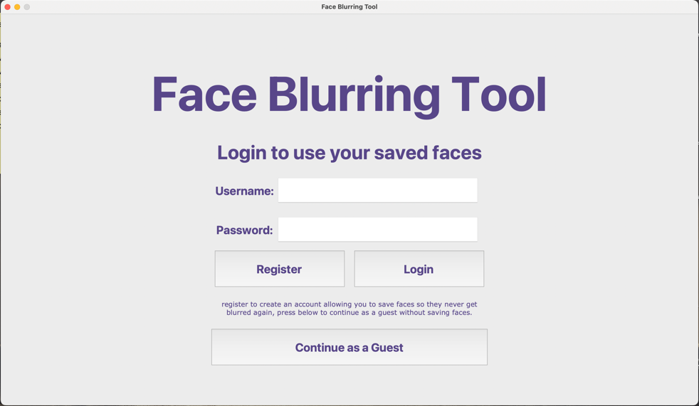

Class above creates this frame

# Class frame for registration screen  
class Registration(tk.Frame):  
 def __init__(self, parent, controller):  
 # inherits tk.Frame characteristics to allow for frames to be brought to front of users screen  
 tk.Frame.__init__(self, parent)  
 # Variables to store username and password entries  
 self.username = tk.StringVar()  
 self.password = tk.StringVar()  
 self.password2 = tk.StringVar()  
 # program title  
 self.title = tk.Label(self, text="Face Blurring Tool", fg="#584689", font=TITLE_FONT)  
 self.title.place(anchor="center", relx=0.5, rely=0.2)  
 # registration screen title  
 self.registertitle = tk.Label(self, text="Account Registration Form", fg="#584689", font=SUBTITLE_FONT_2)  
 self.registertitle.place(anchor="center", relx=0.5, rely=0.35)  
 # Username label text  
 self.usernamelabel = tk.Label(self, text="Username:", fg="#584689", font=SUBTITLE_FONT)  
 self.usernamelabel.place(anchor="center", relx=0.35, rely=0.45)  
 # password label text  
 self.passwordlabel = tk.Label(self, text="Password:", fg="#584689", font=SUBTITLE_FONT)  
 self.passwordlabel.place(anchor="center", relx=0.35, rely=0.55)  
 # re-enter password level text  
 self.password2label = tk.Label(self, text="re-enter\nPassword:", fg="#584689", font=SUBTITLE_FONT)  
 self.password2label.place(anchor="center", relx=0.35, rely=0.64)  
 # Username entry box  
 self.usernameentry = tk.Entry(self, font=SUBTITLE_FONT, justify="center", textvariable=self.username)  
 self.usernameentry.place(anchor="center", relx=0.54, rely=0.45, relwidth=0.29, relheight=0.07)  
 # passwrd entry box  
 self.passwordentry = tk.Entry(self, font=SUBTITLE_FONT, justify="center", show="*", textvariable=self.password)  
 self.passwordentry.place(anchor="center", relx=0.54, rely=0.55, relwidth=0.29, relheight=0.07)  
 # Passowrd re-enter box  
 self.password2entry = tk.Entry(self, font=SUBTITLE_FONT, justify="center", show="*",  
 textvariable=self.password2)  
 self.password2entry.place(anchor="center", relx=0.54, rely=0.65, relwidth=0.29, relheight=0.07)  
 # Button to go back to login screen  
 self.backbutton = tk.Button(self, text="Back", fg="#584689", font=SUBTITLE_FONT,  
 command=lambda: controller.show_frame(Login))  
 self.backbutton.place(anchor="center", relx=0.4, rely=0.75, relwidth=0.19, relheight=0.1)  
 # Button to register after credentials are typed in  
 self.registerbutton = tk.Button(self, text="Register", fg="#584689", font=SUBTITLE_FONT,  
 command=lambda: [DB.register_user(self.username.get(), self.password.get(),  
 self.password2.get()),  
 self.clear_details(), controller.show_frame(Login)  
 if DB.success_check()  
 else (controller.show_frame(Registration))])  
 self.registerbutton.place(anchor="center", relx=0.6, rely=0.75, relwidth=0.19, relheight=0.1)  
 # explanation of all passwor parameters tat have to be met  
 self.password_explained = tk.Label(self, text="Password must be at least 8 characters "  
 "long and should contain at least\n"  
 "one number, one uppercase character "  
 "and one lowercase character.",  
 fg="#FF0000", font=BODY_FONT)  
 self.password_explained.place(anchor="center", relx=0.5, rely=0.85)  
 # method to clear typed in details if user doesnt meet requirements and has to try again  
 def clear_details(self):  
 self.passwordentry.delete(0, 'end')  
 self.password2entry.delete(0, 'end')

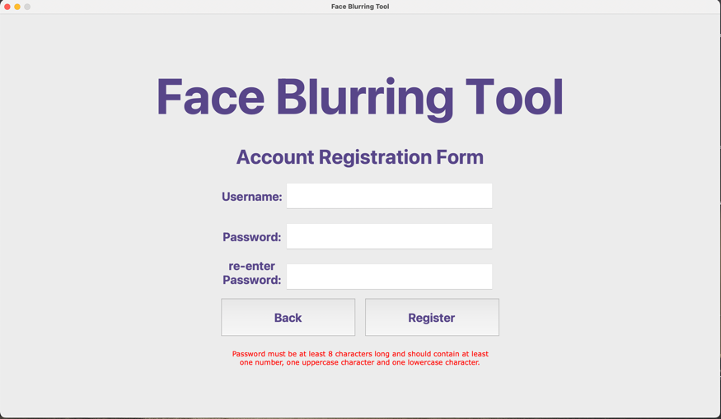

Class above creates this frame

# class for the main menu page of the UI  
class MainMenu(tk.Frame):  
 def __init__(self, parent, controller):  
 # inherits from parent class (BlurringTool) to allow for frames to be brought to front of users screen  
 tk.Frame.__init__(self, parent)  
  
 logout = tk.Button(self, text="Log Out", fg="#584689", font=SUBTITLE_FONT,  
 command=lambda: [DB.logout(), controller.show_frame(Login)])  
 logout.place(anchor="center", relx=0.87, rely=0.05, relwidth=0.15, relheight=0.08)  
  
 # section to place all Tkinter objects onto the main menu frame  
 title = tk.Label(self, text="Face Blurring Tool", fg="#584689", font=TITLE_FONT)  
 title.place(anchor="center", relx=0.5, rely=0.2)  
  
 # button to get to video file selection page  
 button_video = tk.Button(self, text="Video Blurring", fg="#584689", font=SUBTITLE_FONT,  
 command=lambda: [controller.show_frame(PageVideo), ])  
 button_video.place(anchor="center", relx=0.25, rely=0.75, relwidth=0.4, relheight=0.1)  
  
 # button to get to photo file selection page  
 button_photo = tk.Button(self, text="Photo Blurring", fg="#584689", font=SUBTITLE_FONT,  
 command=lambda: controller.show_frame(PagePhoto))  
 button_photo.place(anchor="center", relx=0.75, rely=0.75, relwidth=0.4, relheight=0.1)  
  
 camerapath = Image.open("./GUI/camera.png")  
 cameraimage = ImageTk.PhotoImage(camerapath)  
 camera = tk.Label(self, image=cameraimage)  
 camera.photo = cameraimage  
 camera.place(anchor="center", relx=0.75, rely=0.5)  
  
 videopath = Image.open("./GUI/video.png")  
 videoimage = ImageTk.PhotoImage(videopath)  
 video = tk.Label(self, image=videoimage)  
 video.photo = videoimage  
 video.place(anchor="center", relx=0.25, rely=0.5)

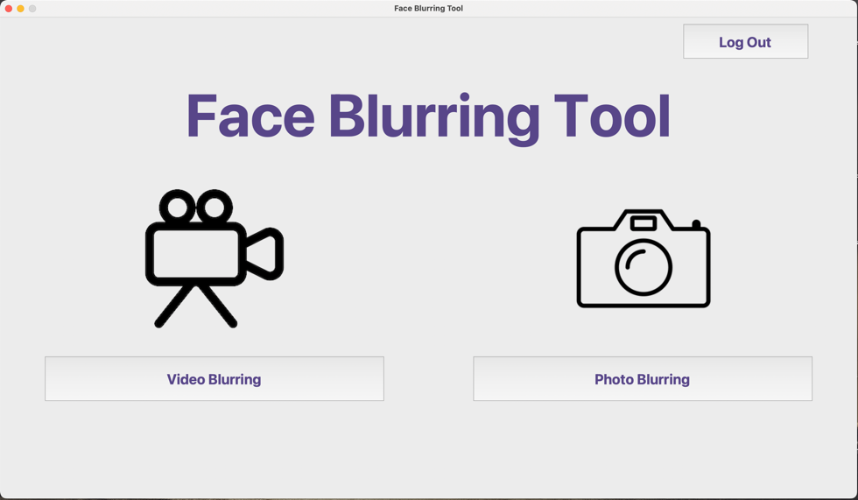

Class above creates this frame

# class for video file selection page of the UI  
class PageVideo(tk.Frame):  
  
 # inherits from parent class (BlurringTool) to allow for frames to be brought to front of users screen  
 def __init__(self, parent, controller):  
 tk.Frame.__init__(self, parent)  
  
 self.bind("<<ShowFrame>>", self.on_show_frame)  
  
 # Variable stores the value of blurring strenght user selects on drag bar  
 self.saveface = IntVar()  
  
 # section for placing objects onto the frame on the GUI  
 header = tk.Label(self, text="File Selection for Video", fg="#584689", font=TITLE_FONT_2)  
 header.place(anchor="center", relx=0.5, rely=0.2)  
  
 # button sends back to main menu  
 button_back = tk.Button(self, text="Back to Main Menu", fg="#584689", font=BODY_FONT,  
 command=lambda: controller.show_frame(MainMenu))  
 button_back.place(anchor="center", relx=0.5, rely=0.05, relwidth=0.2, relheight=0.05)  
  
 # button calls the method in parent class to allow user to select main video file  
 button_selectvideo = tk.Button(self, text="Upload Video", fg="#584689", font=SUBTITLE_FONT,  
 command=lambda: BlurringTool.main_file(parent, "video"))  
 button_selectvideo.place(anchor="center", relx=0.25, rely=0.75, relwidth=0.4, relheight=0.1)  
  
 # button calls method in parent class to allow user to select face photos to avoid in blurring  
 button_selectface = tk.Button(self, text="Upload Faces to Avoid", fg="#584689", font=SUBTITLE_FONT,  
 command=lambda: BlurringTool.avoid_file(parent, self.saveface, 'video'))  
 button_selectface.place(anchor="center", relx=0.75, rely=0.75, relwidth=0.4, relheight=0.1)  
  
 # check box, if ticked face photo uploaded will be saved to database faces.db  
 save_checkbox = tk.Checkbutton(self, text="check to save faces for future use", font=SUBTITLE_FONT,  
 variable=self.saveface, onvalue=1, offvalue=0)  
 save_checkbox.place(anchor="center", relx=0.71, rely=0.85)  
  
 explanation = tk.Label(self, text="(OPTIONAL) Upload images of each face that\n"  
 " should be avoided in the blurring process,\n"  
 " Image should look like the one above", font=BODY_FONT)  
 explanation.place(anchor="center", relx=0.75, rely=0.93)  
 # When button is pressed blurring is applied to all faces in video  
 button_done = tk.Button(self, text="DONE", fg="#584689", font=BODY_FONT,  
 command=lambda: [DB.video_intensity_set(round(self.intense.get())),  
 blur.facelocatevideo(round(self.intense.get())),  
 controller.show_frame(VideoPreview)])  
  
 button_done.place(anchor="center", relx=0.5, rely=0.95, relwidth=0.2, relheight=0.05)  
  
 # button deletes all face photos saved by that user in the database for future use  
 button_clear_saved = tk.Button(self, text="clear saved", fg="#584689", font=BODY_FONT,  
 command=lambda: DB.video_cleartable())  
 button_clear_saved.place(anchor="center", relx=0.91, rely=0.85, relwidth=0.08, relheight=0.05)  
  
 avoidfacepath = Image.open("./GUI/faceavoid.jpg")  
 avoidfaceimage = ImageTk.PhotoImage(avoidfacepath)  
 avoidface = tk.Label(self, image=avoidfaceimage)  
 avoidface.photo = avoidfaceimage  
 avoidface.place(anchor="center", relx=0.75, rely=0.5)  
  
 videofilepath = Image.open("./GUI/videofile.png")  
 videofileimage = ImageTk.PhotoImage(videofilepath)  
 videofile = tk.Label(self, image=videofileimage)  
 videofile.photo = videofileimage  
 videofile.place(anchor="center", relx=0.25, rely=0.5)  
 # drag scale to adjust blurring intensity of faces  
 self.intense = ttk.Scale(self, from_=5, to=10, orient=tk.HORIZONTAL)  
 self.intense.place(anchor="center", relx=0.25, rely=0.82, relwidth=0.4)  
 intensity = tk.Label(self, text="Blurring Intensity", font=SUBTITLE_FONT)  
 intensity.place(anchor="center", relx=0.25, rely=0.87)  
 weak = tk.Label(self, text="weak", font=BODY_FONT)  
 weak.place(anchor="center", relx=0.065, rely=0.87)  
 strong = tk.Label(self, text="strong", font=BODY_FONT)  
 strong.place(anchor="center", relx=0.43, rely=0.87)  
  
 def on_show_frame(self, event):  
 self.intense.set(DB.video_intensity_get())

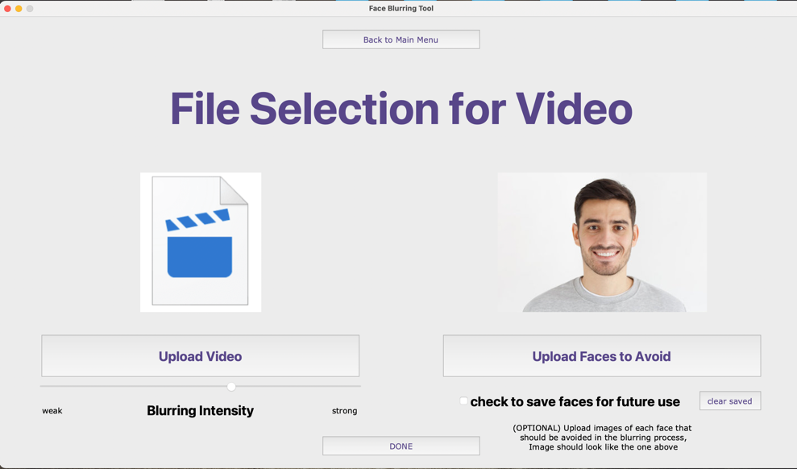

Class above creates this frame

# class for photo file selection page of the UI  
class PagePhoto(tk.Frame):  
  
 # inherits from parent class (BlurringTool) to allow for frames to be brought to front of users screen  
 def __init__(self, parent, controller):  
 tk.Frame.__init__(self, parent)  
  
 self.bind("<<ShowFrame>>", self.on_show_frame)  
  
 # Variable to decide whether face images are saved to database for future blurring  
 self.saveface = IntVar()  
  
 header = tk.Label(self, text="File Selection for Photographs", fg="#584689", font=TITLE_FONT_2)  
 header.place(anchor="center", relx=0.5, rely=0.2)  
  
 # button for user to go back to menu  
 button_back = tk.Button(self, text="Back to Main Menu", fg="#584689", font=BODY_FONT,  
 command=lambda: controller.show_frame(MainMenu))  
 button_back.place(anchor="center", relx=0.5, rely=0.05, relwidth=0.2, relheight=0.05)  
  
 # button to select mail file for blurring to be applied to  
 button_selectphoto = tk.Button(self, text="Upload Photograph", fg="#584689", font=SUBTITLE_FONT,  
 command=lambda: BlurringTool.main_file(parent, "photo"))  
 button_selectphoto.place(anchor="center", relx=0.25, rely=0.75, relwidth=0.4, relheight=0.1)  
  
 # button for user to select photos of faces not to be blurred  
 button_selectface = tk.Button(self, text="Upload Faces to Avoid", fg="#584689", font=SUBTITLE_FONT,  
 command=lambda: BlurringTool.avoid_file(parent, self.saveface.get(), 'photo'))  
 button_selectface.place(anchor="center", relx=0.75, rely=0.75, relwidth=0.4, relheight=0.1)  
  
 # save face checkbox to save faces to avoid on database faces.db for faces not to be blurred in the future  
 save_checkbox = tk.Checkbutton(self, text="check to save faces for future use", font=SUBTITLE_FONT,  
 variable=self.saveface, onvalue=1, offvalue=0)  
 save_checkbox.place(anchor="center", relx=0.71, rely=0.85)  
  
 explanation = tk.Label(self, text="(OPTIONAL) Upload images of each face that\n"  
 " should be avoided in the blurring process,\n"  
 " Image should look like the one above", font=BODY_FONT)  
 explanation.place(anchor="center", relx=0.75, rely=0.93)  
  
 # button to apply blurring to image and go to preview page to see final image  
 button_done = tk.Button(self, text="DONE", fg="#584689", font=BODY_FONT,  
 command=lambda: [DB.photo_intensity_set(round(self.intense.get())),  
 blur.facelocatephoto(round(self.intense.get())),  
 controller.show_frame(PhotoPreview),  
 PhotoPreview.display(parent)])  
 button_done.place(anchor="center", relx=0.5, rely=0.95, relwidth=0.2, relheight=0.05)  
  
 # button to delete all of users saved faces from database.db to allow them to get blurring in images  
 button_clear_saved = tk.Button(self, text="clear saved", fg="#584689", font=BODY_FONT,  
 command=lambda: DB.photo_cleartable())  
 button_clear_saved.place(anchor="center", relx=0.91, rely=0.85, relwidth=0.08, relheight=0.05)  
  
 avoidfacepath = Image.open("./GUI/faceavoid.jpg")  
 avoidfaceimage = ImageTk.PhotoImage(avoidfacepath)  
 avoidface = tk.Label(self, image=avoidfaceimage)  
 avoidface.photo = avoidfaceimage  
 avoidface.place(anchor="center", relx=0.75, rely=0.5)  
  
 photofilepath = Image.open("./GUI/photofile.png")  
 photofileimage = ImageTk.PhotoImage(photofilepath)  
 photofile = tk.Label(self, image=photofileimage)  
 photofile.photo = photofileimage  
 photofile.place(anchor="center", relx=0.25, rely=0.5)  
  
 # drag bar to allow for intensity of blurring of faces to be adjusted before blurring is applied  
 self.intense = ttk.Scale(self, from_=5, to=20, orient=tk.HORIZONTAL)  
 self.intense.place(anchor="center", relx=0.25, rely=0.82, relwidth=0.4)  
 intensity = tk.Label(self, text="Blurring Intensity", font=SUBTITLE_FONT)  
 intensity.place(anchor="center", relx=0.25, rely=0.87)  
 weak = tk.Label(self, text="weak", font=BODY_FONT)  
 weak.place(anchor="center", relx=0.065, rely=0.87)  
 strong = tk.Label(self, text="strong", font=BODY_FONT)  
 strong.place(anchor="center", relx=0.43, rely=0.87)  
  
 def on_show_frame(self, event):  
 self.intense.set(DB.photo_intensity_get())  
  
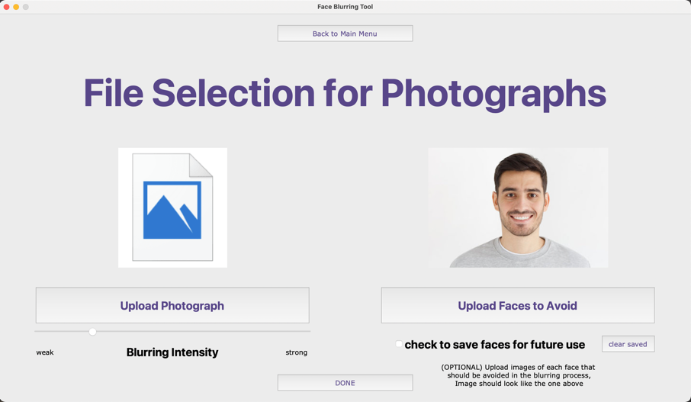

Class above creates this frame

# class of page on UI to select save location of blurred video file and readjust blurring intensity if needed  
class VideoPreview(tk.Frame):  
 def __init__(self, parent, controller):  
 tk.Frame.__init__(self, parent)  
  
 self.bind("<<ShowFrame>>", self.load_video)  
  
 # reblur button allows user to chose intensity and reblur the video if they are unhappy with result  
 button_reblur = tk.Button(self, text="Blur Again", fg="#584689", font=SUBTITLE_FONT,  
 command=lambda: [os.remove("./temp/finished.mp4"),  
 DB.video_intensity_set(round(self.intense.get())),  
 blur.facelocatevideo(round(self.intense.get())),  
 controller.show_frame(VideoPreview)])  
 button_reblur.place(anchor="center", relx=0.25, rely=0.88, relwidth=0.4, relheight=0.07)  
  
 button_back = tk.Button(self, text="Back to Main Menu", fg="#584689", font=BODY_FONT,  
 command=lambda: controller.show_frame(MainMenu))  
 button_back.place(anchor="center", relx=0.75, rely=0.95, relwidth=0.2, relheight=0.05)  
  
 # opens file dialog for user to chose save location of final file  
 button_complete = tk.Button(self, text="Save File and Finish", fg="#584689", font=SUBTITLE_FONT,  
 command=lambda: [blur.savefile("video"),  
 blur.deletefiles(),  
 controller.show_frame(MainMenu)])  
 button_complete.place(anchor="center", relx=0.75, rely=0.88, relwidth=0.4, relheight=0.07)  
  
 # scale to adjust intensity for re-blurring  
 self.intense = ttk.Scale(self, from_=5, to=10, orient=tk.HORIZONTAL)  
 self.intense.place(anchor="center", relx=0.25, rely=0.97, relwidth=0.4)  
 intensity = tk.Label(self, text="Blurring Intensity", font=BODY_FONT)  
 intensity.place(anchor="center", relx=0.25, rely=0.94)  
 weak = tk.Label(self, text="weak", font=BODY_FONT)  
 weak.place(anchor="center", relx=0.065, rely=0.94)  
 strong = tk.Label(self, text="strong", font=BODY_FONT)  
 strong.place(anchor="center", relx=0.43, rely=0.94)  
  
 self.vid_player = TkinterVideo(master=self, pre_load=False, scaled=True)  
 self.vid_player.place(anchor='center', relx=0.5, rely=0.38, relheight=0.75, relwidth=0.8)  
 self.play_pause_btn = tk.Button(self, text='PLAY VIDEO', command=self.play_pause)  
 self.play_pause_btn.place(anchor='center', relx=0.15, rely=0.8, relwidth=0.2, relheight=0.07)  
 self.progress_slider = ttk.Scale(self, from_=0, to=0, orient="horizontal", command=self.seek)  
 self.progress_slider.place(anchor='center', relx=0.6, rely=0.8, relwidth=0.68, relheight=0.07)  
 self.end_time = tk.Label(self, text=str(datetime.timedelta(seconds=0)))  
 self.end_time.place(anchor='center', relx=0.97, rely=0.8)  
  
 self.vid_player.bind("<<Duration>>", self.update_duration)  
 self.vid_player.bind("<<SecondChanged>>", self.update_scale)  
 self.vid_player.bind("<<Ended>>", self.video_ended)  
  
 def update_duration(self, event):  
 # updates the duration after finding the duration  
 self.end_time["text"] = str(datetime.timedelta(seconds=self.vid_player.duration()))[:10]  
 self.progress_slider["to"] = self.vid_player.duration()  
  
 def update_scale(self, event):  
 # updates the scale value  
 self.progress_slider.set(self.vid_player.current_duration())  
  
 def load_video(self, event):  
 # sets users saved blurring intensity  
 self.intense.set(DB.video_intensity_get())  
 # loads the video  
 file_pathname = "./temp/finished.mp4"  
  
 self.vid_player.load(file_pathname)  
  
 self.progress_slider.config(to=0, from_=0)  
 self.progress_slider.set(0)  
 self.play_pause_btn["text"] = "Play"  
  
 def seek(self, value):  
 # used to seek a specific timeframe  
 self.vid_player.seek(int(float(value)))  
  
 def skip(self, value):  
 # skip seconds  
 self.vid_player.skip_sec(int(float(value)))  
 self.progress_slider.set(self.progress_slider.get() + int(float(value)))  
  
 def play_pause(self):  
 # pauses and plays  
 if self.vid_player.is_paused():  
 self.vid_player.play()  
 self.play_pause_btn["text"] = "Pause"  
  
 else:  
 self.vid_player.pause()  
 self.play_pause_btn["text"] = "Play"  
  
 def video_ended(self, event):  
 # handle video ended  
 self.progress_slider.set(self.progress_slider["to"])  
 self.play_pause_btn["text"] = "Play"  
  
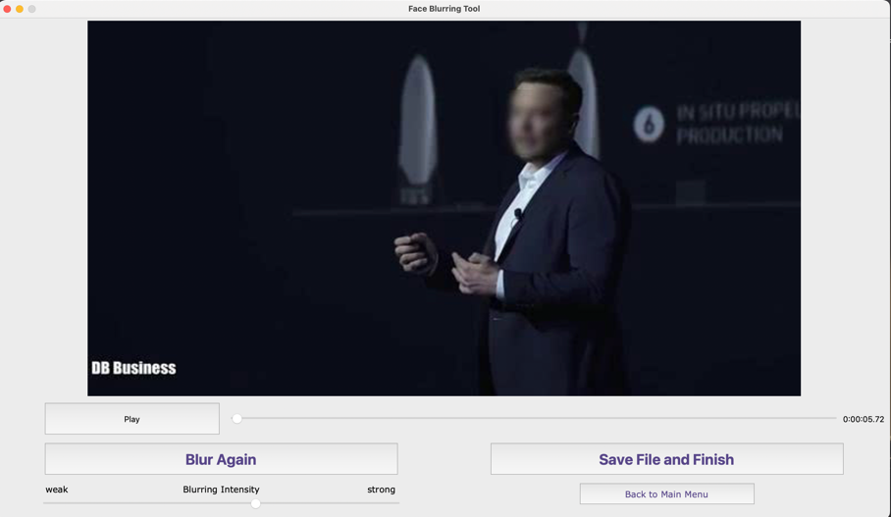

Methods in the class VideoPreview control playback of blurred video when user is previewing before saving

Class above creates this frame

# class of page on UI to select save location of blurred photo file and readjust blurring intensity if needed  
class PhotoPreview(tk.Frame):  
 def __init__(self, parent, controller):  
 tk.Frame.__init__(self, parent)  
  
 self.bind("<<ShowFrame>>", self.on_show_frame)  
  
 # button to reblur image if user is unhappy with blurred result  
 button_reblur = tk.Button(self, text="Blur Again", fg="#584689", font=SUBTITLE_FONT,  
 command=lambda: [os.remove("./temp/finished.jpg"),  
 DB.photo_intensity_set(round(self.intense.get())),  
 blur.facelocatephoto(round(self.intense.get())),  
 controller.show_frame(PhotoPreview),  
 PhotoPreview.display(parent)])  
 button_reblur.place(anchor="center", relx=0.25, rely=0.80, relwidth=0.4, relheight=0.1)  
  
 # opens file dialog for user to chose save location of final file  
 button_complete = tk.Button(self, text="Save File and Finish", fg="#584689", font=SUBTITLE_FONT,  
 command=lambda: [blur.savefile("photo"),  
 blur.deletefiles(),  
 controller.show_frame(MainMenu)])  
 button_complete.place(anchor="center", relx=0.75, rely=0.80, relwidth=0.4, relheight=0.1)  
  
 button_back = tk.Button(self, text="Back to Main Menu", fg="#584689", font=BODY_FONT,  
 command=lambda: controller.show_frame(MainMenu))  
 button_back.place(anchor="center", relx=0.75, rely=0.95, relwidth=0.2, relheight=0.05)  
  
 # scale to adjust intensity for re-blurring  
 self.intense = ttk.Scale(self, from_=5, to=20, orient=tk.HORIZONTAL)  
 self.intense.place(anchor="center", relx=0.25, rely=0.87, relwidth=0.4)  
 intensity = tk.Label(self, text="Blurring Intensity", font=SUBTITLE_FONT)  
 intensity.place(anchor="center", relx=0.25, rely=0.92)  
 weak = tk.Label(self, text="weak", font=BODY_FONT)  
 weak.place(anchor="center", relx=0.065, rely=0.92)  
 strong = tk.Label(self, text="strong", font=BODY_FONT)  
 strong.place(anchor="center", relx=0.43, rely=0.92)  
  
 def on_show_frame(self, event):  
 self.intense.set(DB.photo_intensity_get())  
  
 # method to load preview of blurred image for user to decide if they want to reblur it  
 def display(self):  
 photo = Image.open("./temp/finished.jpg")  
 width, height = photo.size  
 ratio = width/height  
 photo = photo.resize((700, int(700/ratio)))  
 photoimage = ImageTk.PhotoImage(photo)  
 photopreview = tk.Label(self, image=photoimage)  
 photopreview.photo = photoimage  
 photopreview.place(anchor="center", relx=0.5, rely=0.35)

This method is used to resize and place the blurred image on the frame for user to preview it before saving

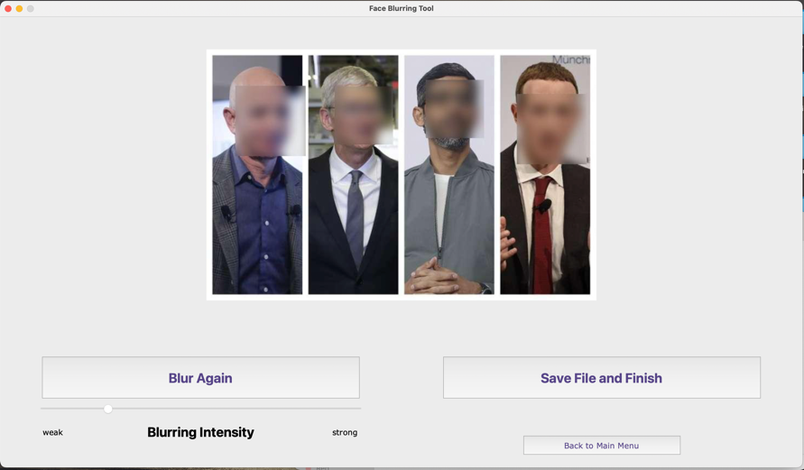  
  
  
# program section to call the master class and start the program setting window size  
if __name__ == "__main__":  
 blur.deletefiles()  
 FaceBlurTool = BlurringTool()  
 FaceBlurTool.geometry("1440x810")  
 FaceBlurTool.mainloop()

Class above creates this frame

## **Face Detecting and Blurring algorithm facebluralg.py**

import face_recognition  
from PIL import Image  
import os  
import cv2  
import matlab.engine  
import shutil  
from tkinter.filedialog import asksaveasfilename  
  
  
class FaceBlurAlgorithm:  
 def __init__(self):  
 self.eng = matlab.engine.start_matlab()  
  
 # method to detect all the faces in the main image  
 def facelocatephoto(self, intense):  
 # List that will contain all faces that should NOT be blurred  
 ignore_face_encodings = []  
 # For loop to append all faces provided by user to be ignored into ignore face list  
 for file in os.listdir("ignore"):  
 # Only reads image files ignoring all system files  
 if not file.startswith("."):  
 known_face = face_recognition.load_image_file(f"./ignore/{file}")  
 # attempts to detect face in each image appending it to list if face is found  
 try:  
 known_face_encoding = face_recognition.face_encodings(known_face)[0]  
 ignore_face_encodings.append(known_face_encoding)  
 # Except statement to go to next image if no face is detected  
 except IndexError:  
 pass  
  
 # Load main image to find faces for blurring  
 main_image = face_recognition.load_image_file("./main/main.jpg")  
  
 # Find the coordinates of each face in the main image  
 face_locations = face_recognition.face_locations(main_image)  
 # creates encodings for the faces to later be compared with the encodings for faces to be ignored  
 face_encodings = face_recognition.face_encodings(main_image, face_locations)  
  
 # Convert to PIL format to allow image formatting and comparison of encodings  
 pil_image = Image.fromarray(main_image)  
  
 # Runs the function to blur the faces  
 self.blurfaces(pil_image, face_locations, face_encodings, ignore_face_encodings, int(intense))  
  
 # saves completed image in temporary file  
 pil_image.save("./temp/finished.jpg")  
  
  
 def facelocatevideo(self, intense):  
 # List that will contain all faces that should NOT be blurred  
 ignore_face_encodings = []  
 # For loop to append all faces provided by user to be ignored into ignore face list  
 for file in os.listdir("ignore"):  
 # Only reads image files ignoring all system files  
 if not file.startswith("."):  
 known_face = face_recognition.load_image_file(f"./ignore/{file}")  
 # attempts to detect face in each image appending it to list if face is found  
 try:  
 known_face_encoding = face_recognition.face_encodings(known_face)[0]  
 ignore_face_encodings.append(known_face_encoding)  
 # Except statement to go to next image if no face is detected  
 except IndexError:  
 pass  
 video = cv2.VideoCapture("./main/main.mp4")  
  
 frame_width = int(video.get(3))  
 frame_height = int(video.get(4))  
 frame_size = (frame_width, frame_height)  
 fps = int(video.get(5))  
 output = cv2.VideoWriter('./temp/finished.mp4',  
 cv2.VideoWriter_fourcc('m', 'p', '4', 'v'), fps,  
 frame_size)  
  
 while video.isOpened():  
 out, image = video.read()  
  
 if not out:  
 break  
 image = cv2.cvtColor(image, cv2.COLOR_BGR2RGB)  
  
 # Find the coordinates of each face in the main image  
 face_locations = face_recognition.face_locations(image)  
 # creates encodings for the faces to later be compared with the encodings for faces to be ignored  
 face_encodings = face_recognition.face_encodings(image, face_locations)  
  
 # Convert to PIL format to allow image formatting and comparison of encodings  
 pil_image = Image.fromarray(image)  
  
 # Runs the function to blur the faces  
 self.blurfaces(pil_image, face_locations, face_encodings, ignore_face_encodings, int(intense))  
  
 pil_image.save("./temp/video.jpg")  
  
 frame = cv2.imread("./temp/video.jpg")  
  
 output.write(frame)  
  
 os.remove("./temp/video.jpg")  
  
 video.release()  
 output.release()  
  
 # method to blur faces  
 def blurfaces(self, pil_image, face_locations, face_encodings, ignore_face_encodings, intense):  
 # Loop through faces in main image  
 for (top, right, bottom, left), face_encoding in zip(face_locations, face_encodings):  
 # Compare the faces detected in main image with the faces in list of faces to ignore  
 matches = face_recognition.compare_faces(ignore_face_encodings, face_encoding, tolerance=0.6)  
 # if current face does not match faces in faces to ignore list blurring is applied  
 if True not in matches:  
 # Checks to ensure face blurring algorithm does not go outside image  
 width, height = pil_image.size  
 if top < intense:  
 top = intense  
 elif bottom > height - intense:  
 bottom = height - intense  
 if left < intense:  
 left = intense  
 elif right > width - intense:  
 right = width - intense  
 face = pil_image.crop((left - intense, top - intense, right + intense, bottom + intense))  
 face.save("./temp/before.jpg")  
 name = os.path.realpath("./temp/before.jpg")  
 self.eng.gaussianblur(name, float(intense), nargout=0)  
 # Calls the blur function  
 blurredface = Image.open("./temp/face.jpg")  
 blurredfacefinal = blurredface.crop((intense, intense, (right - left + intense),  
 (bottom - top + intense)))  
 # Pastes the blurred face back onto the image  
 pil_image.paste(blurredfacefinal, (left, top))  
 os.remove("./temp/face.jpg")  
 os.remove("./temp/before.jpg")  
  
 # method to delete files after program has been executed  
 def deletefiles(self):  
 # For loop through all images to be ignored  
 for f in os.listdir("ignore"):  
 # Ignores all system files  
 if not f.startswith("."):  
 # deletes the image file  
 os.remove(f"./ignore/{f}")  
 # Delete the main image file  
 try:  
 os.remove("./main/main.jpg")  
 os.remove("./temp/finished.jpg")  
 except FileNotFoundError:  
 try:  
 os.remove("./main/main.mp4")  
 os.remove("./temp/finished.mp4")  
 except FileNotFoundError:  
 pass  
  
 # method to save final blurred file  
 def savefile(self, filetype):  
 # file type validation, if main file is image these lines of code will execute  
 if filetype == 'photo':  
 location = asksaveasfilename(defaultextension=".jpg")  
 shutil.copy('./temp/finished.jpg', location)  
 # file type validation, if main file is a video these lines of code will execute  
 else:  
 location = asksaveasfilename(defaultextension=".mp4")  
 shutil.copy('./temp/finished.mp4', location)

Stores x and y locations of all faces in main image

Stores face encoding of all faces in main image

List with encoding of faces that wont be blurred

Starts the MATLAB engine to be able to run gaussianblur.m program when blurring process is reached

List storing face encodings of faces that will not be blurred

Video opened using CV2 format to access each frame separately

Frame converted to PIL image format to blur using Blurfaces method

Process explained in next method of this program

After each face in each frame is blurred, the video is reconstructed out of the new frames

Compares current face with ignore face list, if it doesn’t match any faces to ignore, face is cropped with extra pixels padded around it for gaussian function to work

gaussianblur.m MATLAB program is called to blur the current face. Program process explained with next program

Blurred face pasted back onto original image removing the temporary files created in blurring process automatically

Method to delete all temporary files created

Method for user to be asked where to save blurred image/video, and save the file in corresponding location

## **MATLAB blurring Algorithm gaussianblur.m**

Takes input of face image location and blurring strength(sz)

function gaussianblur(ImgName, sz)

Img=imread(ImgName);

%Read the Image file

I = double(Img);

%Design the Gaussian Kernel using 3d gaussian function

%Standard Deviation to measure the width and height of kernel

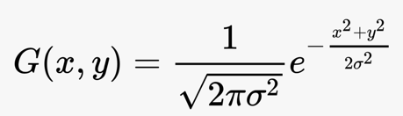 sigma = ceil(sz/2);

[x,y]=meshgrid(-sz:sz,-sz:sz);

width = size(x,1)-1;

height = size(y,1)-1;

Equation = -(x.^2+y.^2)/(2*sigma*sigma);

Kernel= (exp(Equation)/(2*pi*sigma*sigma));

Kernel that is created looks like image to the left the higher the blurring strength, the bigger the kernel, the kernel just gives weightings to rgb values in next calculation.

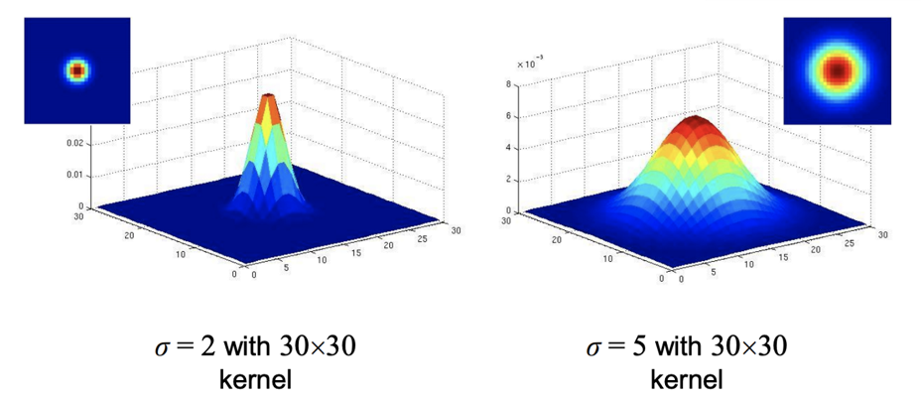

%Initialize the matrix/3darray to manipulate rgb values of image

imar=I;

%Pad the vector with zeros to ensure the blurring does not go

%outside the image causing error

I = padarray(I,[sz sz]);

%Convolution of the kernel, gaussian function applied to every

%pixel in image of the face

for i = 1:size(I,1)-width

Nested for loop goes through every x and y coordinate in the face image, RED, BLUE and GREEN values of each pixel are recalculated using averages given by multiplying corresponding pixels by values in the gaussian kernel.

for j = 1:size(I,2)-height

p=i+width;

q=j+height;

temp1 = I(i:p,j:q,1).*Kernel;

temp2 = I(i:p,j:q,2).*Kernel;

temp3 = I(i:p,j:q,3).*Kernel;

imar(i,j,1)=sum(temp1(:));

imar(i,j,2)=sum(temp2(:));

imar(i,j,3)=sum(temp3(:));

end

end

%Blurred image of face after Gaussian blur has been applied is saved

%into temp folder to be pasted into original image.

out = uint8(imar);

imwrite(out,'./temp/face.jpg','jpg')

end

Saves blurred face to temporary file for main program to paste onto main image

## **SQLite3 Database program database.py**

import sqlite3  
from tkinter import messagebox  
# importing class from hashalg.py program  
from hashalg import Hashing  
  
# objects imported from my other python files  
hash_function = Hashing()  
  
  
class Database:  
 def __init__(self):  
 # connect the local sqlite database  
 self.MyDB = sqlite3.connect("faces.db")  
  
 # set the cursor to access the table  
 self.MyCursor = self.MyDB.cursor()  
  
 # creates the user table  
 self.MyCursor.execute("CREATE TABLE IF NOT EXISTS tblUsers ("  
 "UserID INTEGER NOT NULL, "  
 "Username VARCHAR(255) NOT NULL, "  
 "Password VARCHAR(255) NOT NULL, "  
 "VideoSetting DECIMAL(5,10), "  
 "PhotoSetting DECIMAL(5,20), "  
 "PRIMARY KEY (UserID))")  
  
 # creates the photo table in the database to save faces for photo blurring  
 self.MyCursor.execute("CREATE TABLE IF NOT EXISTS tblPhoto ("  
 "PhotoID INTEGER NOT NULL, "  
 "UserID INTEGER NOT NULL, "  
 "PhotoFace MEDIUMBLOB NOT NULL, "  
 "PRIMARY KEY (PhotoID)"  
 "FOREIGN KEY (UserID) REFERENCES tblUsers (UserID))")  
  
 # creates the video table in the database to save faces for video blurring  
 self.MyCursor.execute("CREATE TABLE IF NOT EXISTS tblVideo ("  
 "VideoID INTEGER NOT NULL, "  
 "UserID INTEGER NOT NULL, "  
 "VideoFace MEDIUMBLOB NOT NULL, "  
 "PRIMARY KEY (VideoID)"  
 "FOREIGN KEY (UserID) REFERENCES tblUsers (UserID))")  
  
 self.MyDB.commit()  
  
 self.UserID = 0  
  
 self.success = False  
  
 # Method to ensure user disconnects from database when logged out  
 def logout(self):  
 self.UserID = 0  
  
 # Method to login and search for user in database  
 def find_user(self, username, password, usertype):  
 # hashes inputted username and password  
 username = hash_function.sha256(username)  
 password = hash_function.sha256(password)  
 if usertype == 'guest':  
 self.UserID = 'guest'  
 else:  
 statement = f"SELECT * FROM tblUsers WHERE Username='{username}' AND Password = '{password}';"  
 self.MyCursor.execute(statement)  
 result = self.MyCursor.fetchone()  
 # user was not found in the database or incorrect login data entered  
 if not result:  
 messagebox.showinfo("User Not Found", "User Not Found\n\n"  
 "Please make sure correct username and\n"  
 "password were entered and try again")  
 else:  
 self.UserID = result[0]  
 # Method to register a new user  
 def register_user(self, username, password, password2):  
 # password strength parameters checked  
 weaknesses = 3  
 if any('a' <= character <= 'z' for character in password):  
 weaknesses -= 1  
 if any('A' <= character <= 'Z' for character in password):  
 weaknesses -= 1  
 if any(character.isdigit() for character in password):  
 weaknesses -= 1  
 # check if username already exists in database  
 username_statement = f"SELECT * FROM tblUsers WHERE Username='{hash_function.sha256(username)}'"  
 self.MyCursor.execute(username_statement)  
 if self.MyCursor.fetchone():  
 # error message that username already in use  
 messagebox.showinfo("Username already exists", "Username already exists\n\n"  
 "Please enter a new Username and retype passwords\n"  
 "and try again by pressing Register")  
 # error message in username too long  
 elif len(username) > 15:  
 messagebox.showinfo("Username is too long", "Username is too long\n\n"  
 "Username should not exceed 15 characters in length")  
 # error message if username too short  
 elif len(username) < 3:  
 messagebox.showinfo("Username is too short", "Username is too short\n\n"  
 "Username should not be less than 3 characters in length")  
 # error message if password and retyped password do not match  
 elif password != password2:  
 messagebox.showinfo("Passwords do not match", "Passwords do not match\n\n"  
 "Please enter passwords again and press Register")  
 # error message if password too short  
 elif len(password) < 8:  
 messagebox.showinfo("Password is too short", "Password is too short\n\n"  
 "Please ensure password is at least 8 characters long")  
 # error message if password doesn't meet all strength requirements  
 elif weaknesses != 0:  
 messagebox.showinfo("Password does not meet all strength requirement",  
 "Password does not meet all strength requirement\n\n"  
 "Please ensure password contains\n"  
 "at least one lowercase character, "  
 "one uppercase character and"  
 "one numerical digit.")  
 else:  
 # If there are no errors new user is added to tblUsers in the database  
 username = hash_function.sha256(username)  
 password = hash_function.sha256(password)  
 register_statement = f"INSERT INTO tblUsers(Username, Password, VideoSetting, PhotoSetting)" \  
 f"VALUES ('{username}','{password}',8,8)"  
 self.MyCursor.execute(register_statement)  
 self.MyDB.commit()  
 # registered successfully message shown and user is sent back to login screen  
 messagebox.showinfo("Registered Successfully", "Registered Successfully\n\n "  
 "Login with your new account")  
 self.success = True  
  
 def success_check(self):  
 x = self.success  
 self.success = False  
 return x  
  
 # Method that finds the users last used video intensity  
 def video_intensity_get(self):  
 # if user is guest then default intensity is set  
 if self.UserID == 'guest':  
 return 8  
 else:  
 statement = f"SELECT * FROM tblUsers WHERE UserID = {self.UserID}"  
 self.MyCursor.execute(statement)  
 result = self.MyCursor.fetchone()  
 return round(result[3])  
  
 # Method that finds the users last used video blurring intensity  
 def video_intensity_set(self, intensity):  
 if self.UserID == 'guest':  
 pass  
 else:  
 statement = f"UPDATE tblUsers SET VideoSetting = {intensity} WHERE UserID = {self.UserID}"  
 self.MyCursor.execute(statement)  
 self.MyDB.commit()  
  
 # Method that finds the users last used photo blurring intensity  
 def photo_intensity_get(self):  
 # if user is guest then default intensity is set  
 if self.UserID == 'guest':  
 return 8  
 else:  
 statement = f"SELECT * FROM tblUsers WHERE UserID = {self.UserID}"  
 self.MyCursor.execute(statement)  
 result = self.MyCursor.fetchone()  
 return round(result[4])  
   
 # Method that saves last used blurring intensity of user to keep for later login and use  
 def photo_intensity_set(self, intensity):  
 if self.UserID == 'guest':  
 pass  
 else:  
 statement = f"UPDATE tblUsers SET PhotoSetting = {intensity} WHERE UserID = {self.UserID}"  
 self.MyCursor.execute(statement)  
 self.MyDB.commit()  
  
 # Method to insert face images to save for future if user ticks off save tick box  
 def video_insert_images(self, filepaths):  
 if self.UserID == 'guest':  
 pass  
 else:  
 for i in filepaths:  
 with open(i, "rb") as File:  
 binarydata = File.read()  
 insert_blob_query = "INSERT INTO tblVideo (UserID,VideoFace) VALUES (?,?)"  
 self.MyCursor.execute(insert_blob_query, (self.UserID, binarydata))  
 self.MyDB.commit()  
   
 # Method to insert face images to save for future if user ticks off save tick box  
 def photo_insert_images(self, filepaths):  
 if self.UserID == 'guest':  
 pass  
 else:  
 for i in filepaths:  
 with open(i, "rb") as File:  
 binarydata = File.read()  
 insert_blob_query = "INSERT INTO tblPhoto (UserID,PhotoFace) VALUES (?,?)"  
 self.MyCursor.execute(insert_blob_query, (self.UserID, binarydata))  
 self.MyDB.commit()  
   
 # Method to run sql query to retrieve current users saved face images to ignore in blurring  
 def video_retrieve_images(self):  
 if self.UserID == 'guest':  
 pass  
 else:  
 sqlstatement2 = f"SELECT VideoFace FROM tblVideo WHERE UserID = {self.UserID}"  
 self.MyCursor.execute(sqlstatement2)  
 result = self.MyCursor.fetchall()  
 for i in result:  
 image = f"./ignore/saved{result.index(i)}.jpg"  
 with open(image, "wb") as File:  
 File.write(i[0])  
 File.close()  
  
 # Method to run sql query to retrieve current users saved face images to ignore in blurring  
 def photo_retrieve_images(self):  
 if self.UserID == 'guest':  
 pass  
 else:  
 sqlstatement2 = f"SELECT PhotoFace FROM tblPhoto WHERE UserID = {self.UserID}"  
 self.MyCursor.execute(sqlstatement2)  
 result = self.MyCursor.fetchall()  
 for i in result:  
 image = f"./ignore/saved{result.index(i)}.jpg"  
 with open(image, "wb") as File:  
 File.write(i[0])  
 File.close()  
  
 # Method to run sql query to delete current users saved faces in photo table  
 def photo_cleartable(self):  
 delete_query = f"DELETE from tblPhoto WHERE UserID = {self.UserID}"  
 self.MyCursor.execute(delete_query)  
 self.MyDB.commit()  
   
 # Method to run sql query to delete current users saved faces in video table  
 def video_cleartable(self):  
 delete_query = f"DELETE from tblVideo WHERE UserID = {self.UserID}"  
 self.MyCursor.execute(delete_query)  
 self.MyDB.commit()

Creates object from Hashing class in my other program, to use its methods to hash usernames and passowrds

CREATE TABLE tblPhoto storing images of faces to be ignored in the blurring process of Photos

CREATE TABLE tblVideo storing images of faces to be ignored in the blurring process of Videos

CREATE TABLE tblUsers storing hashed login and user settings

Method to compare login data to users in database, if match is found user logs in and current UserID is found to access users data

Method to register user with password strength checking algorithm and check whether username is unique

Method allows main program to open login frame if user registers successfully

Retrieves users last used video blurring intensity and sets that intensity

If user changes video blurring intensity, last used intensity is saved using this method

Method retrieves last used blurring intensity of photos for current user, and sets the intensity to that

If user changes blurring intensity of photos, this method will save this intensity to the database to set for future.

Saves faces of images user doesn’t want blurred to database when save tick box is checked in tblVideo

Saves faces of images user doesn’t want blurred to database when save tick box is checked in tblPhoto

Retrieves saved faces in video blurring to prevent users saved faces from getting blurred

Retrieves saved faces in photo blurring to prevent users saved faces from getting blurred

Deletes all of current users saved faces in the database for either photo blurring or

video blurring

## **Hashing algorithm using SHA256 hashalg.py**

# performs logical AND operation on items in lists (A AND B)  
def list_and(i, j): return [A & B for A, B in zip(i, j)]  
  
  
# performs logical NOT operation on items in lists  
def list_not(i): return [~x for x in i]  
  
  
# performs logical XOR operation on items in lists  
def list_xor(i, j): return [A ^ B for A, B in zip(i, j)]  
  
  
# performs logical XOR operation on 3 consecutive items in list (A XOR (B XOR C))  
def list_double_xor(i, j, k): return [A ^ (B ^ C) for A, B, C, in zip(i, j, k)]  
  
  
# performs rotation rightwards of items in a list by n places (x = [1,2,3,4,5], list_rotate(x,2) = [5,4,1,2,3])  
def list_rotate(x, n): return x[-n:] + x[:-n]  
  
  
# shifts items rightwards in the list by n places (x = [1,2,3,4,5], list_shift(x,2) = [0,0,5,4,3]  
def list_shift(x, n): return n * [0] + x[:-n]  
  
  
# performs binary addition of items of two lists getting rid of carry over bits beyond set length  
def list_add(i, j):  
 length = len(i)  
 added = list(range(length))  
 c = 0  
 for x in range(length-1, -1, -1):  
 added[x] = i[x] ^ (j[x] ^ c)  
 c = max([i[x], j[x]], key=[i[x], j[x], c].count)  
 return added  
  
  
class Hashing:  
 def __init__(self):  
 # hash values which are the first 32 bits of the fractional parts of the square roots of the first 8 primes  
 self.hex = ['0x6a09e667', '0xbb67ae85', '0x3c6ef372', '0xa54ff53a',  
 '0x510e527f', '0x9b05688c', '0x1f83d9ab', '0x5be0cd19']  
  
 # constants which are the first 32 bits of the fractional parts of the cube roots of the first 64 primes  
 self.constants = ['0x428a2f98', '0x71374491', '0xb5c0fbcf', '0xe9b5dba5', '0x3956c25b', '0x59f111f1',  
 '0x923f82a4', '0xab1c5ed5', '0xd807aa98', '0x12835b01', '0x243185be', '0x550c7dc3',  
 '0x72be5d74', '0x80deb1fe', '0x9bdc06a7', '0xc19bf174', '0xe49b69c1', '0xefbe4786',  
 '0x0fc19dc6', '0x240ca1cc', '0x2de92c6f', '0x4a7484aa', '0x5cb0a9dc', '0x76f988da',  
 '0x983e5152', '0xa831c66d', '0xb00327c8', '0xbf597fc7', '0xc6e00bf3', '0xd5a79147',  
 '0x06ca6351', '0x14292967', '0x27b70a85', '0x2e1b2138', '0x4d2c6dfc', '0x53380d13',  
 '0x650a7354', '0x766a0abb', '0x81c2c92e', '0x92722c85', '0xa2bfe8a1', '0xa81a664b',  
 '0xc24b8b70', '0xc76c51a3', '0xd192e819', '0xd6990624', '0xf40e3585', '0x106aa070',  
 '0x19a4c116', '0x1e376c08', '0x2748774c', '0x34b0bcb5', '0x391c0cb3', '0x4ed8aa4a',  
 '0x5b9cca4f', '0x682e6ff3', '0x748f82ee', '0x78a5636f', '0x84c87814', '0x8cc70208',  
 '0x90befffa', '0xa4506ceb', '0xbef9a3f7', '0xc67178f2']  
  
 def string_to_binary(self, text):  
 # converts the text to integer representation in unicode  
 utf_codes = [ord(char) for char in text]  
 # converts unicode integers to binary bytes  
 binarybytes = []  
 for char in utf_codes:  
 binarybytes.append(bin(char)[2:].zfill(8))  
 # splits bytes into bits and converts to integers from strings  
 bits = []  
 for i in binarybytes:  
 for bit in i:  
 bits.append(int(bit))  
 return bits  
  
 def bin_to_hex(self, value):  
 # stores binary list as a string to convert to hexadecimal  
 string = ''  
 for i in value:  
 string += str(i)  
 x = hex(int('0b' + string, 2))  
 # stores the hex value without python datatype identifier  
 hexes = x[2:]  
 return hexes  
  
 def chunker(self, bits, length=8):  
 # splits up the bits into byte chunks  
 chunks = []  
 for i in range(0, len(bits), length):  
 chunks.append(bits[i:i+length])  
 return chunks  
  
 def pad_zeroes(self, bits, length=8, endian='little'):  
 # append zeroes or prepends zeroes until the desired length of bits is reached  
 x = len(bits)  
 # if endian is little then appends zeroes after the bits  
 if endian == 'little':  
 for i in range(x, length):  
 bits.append(0)  
 # if endian is big then inserts zeroes before the bits  
 else:  
 for j in range(length - x):  
 bits.insert(0, 0)  
 return bits  
  
 def pad_message(self, text):  
 # translate message into bits  
 bits = self.string_to_binary(text)  
 length = len(bits)  
 # get length in bits of message in 64 bit blocks  
 text_len = [int(b) for b in bin(length)[2:].zfill(64)]  
 # if length smaller than 448 handle block individually otherwise  
 # pads with zeroes till length is 64 characters short of a multiple of 512  
 if length < 448:  
 # append single 1  
 bits.append(1)  
 # pads the zeroes  
 bits = self.pad_zeroes(bits, 448, 'little')  
 bits = bits + text_len  
 return [bits]  
 elif 448 <= length <= 512:  
 # append single 1  
 bits.append(1)  
 # pads the zeroes  
  
 bits = self.pad_zeroes(bits, 1024, 'little')  
 # last 64 bits represent original message length  
 bits[-64:] = text_len  
 return self.chunker(bits, 512)  
 else:  
 bits.append(1)  
 # loop until multiple of 512 if message is longer than 448 bits  
 while len(bits) % 512 != 0:  
 bits.append(0)  
 # last 64 bits represent original message length  
 bits[-64:] = text_len  
 return self.chunker(bits, 512)  
  
 def words_to_32bit(self, values):  
 # converts from hex to binary without python datatype code  
 binaries = [bin(int(v, 16))[2:] for v in values]  
 # creates 2D list containing 32 bit words in binary  
 words = []  
 for binary in binaries:  
 word = []  
 for b in binary:  
 word.append(int(b))  
 # pad zeroes before word to make 32 bit length  
 words.append(self.pad_zeroes(word, 32, 'big'))  
 return words  
  
 def sha256(self, text):  
 # converts hard coded constants into 32bit  
 k = self.words_to_32bit(self.constants)  
 # converts hard coded hash values into 32bit  
 h0, h1, h2, h3, h4, h5, h6, h7 = self.words_to_32bit(self.hex)  
 # splits up input text into chunks  
 chunks = self.pad_message(text)  
 for chunk in chunks:  
 words = self.chunker(chunk, 32)  
 for x in range(48):  
 # add 48 empty words to list to make 64 total words  
 words.append(32*[0])  
 for i in range(16, 64):  
 # performs SHA256 hash function on list of words  
 # xor operation on items in three lists  
 # binary rotation on two lists and logical shift right on third list  
 sigma0 = list_double_xor(list_rotate(words[i - 15], 7),  
 list_rotate(words[i - 15], 18), list_shift(words[i - 15], 3))  
 sigma1 = list_double_xor(list_rotate(words[i - 2], 17), list_rotate(words[i - 2], 19),  
 list_shift(words[i - 2], 10))  
 words[i] = list_add(list_add(list_add(words[i - 16], sigma0), words[i - 7]), sigma1)  
 a = h0  
 b = h1  
 c = h2  
 d = h3  
 e = h4  
 f = h5  
 g = h6  
 h = h7  
 for j in range(64):  
 # xor operation on items in three lists  
 # logical rotate right items in list one, two and three  
 sigma1 = list_double_xor(list_rotate(e, 6), list_rotate(e, 11), list_rotate(e, 25))  
 # xor operation on items in two lists  
 ch = list_xor(list_and(e, f), list_and(list_not(e), g))  
 # binary adittion of items in two lists  
 temp1 = list_add(list_add(list_add(list_add(h, sigma1), ch), k[j]), words[j])  
 # xor operation on items in three lists  
 # binary rotate of items in all three lists  
 sigma0 = list_double_xor(list_rotate(a, 2), list_rotate(a, 13), list_rotate(a, 22))  
 # xor operation on items in three lists  
 # logical AND of hash values a, b and c  
 m = list_double_xor(list_and(a, b), list_and(a, c), list_and(b, c))  
 temp2 = list_add(sigma0, m)  
 h = g  
 g = f  
 f = e  
 e = list_add(d, temp1)  
 d = c  
 c = b  
 b = a  
 a = list_add(temp1, temp2)  
 h0 = list_add(h0, a)  
 h1 = list_add(h1, b)  
 h2 = list_add(h2, c)  
 h3 = list_add(h3, d)  
 h4 = list_add(h4, e)  
 h5 = list_add(h5, f)  
 h6 = list_add(h6, g)  
 h7 = list_add(h7, h)  
 # creates an output variable to stored hashed value of inputted text  
 output = ''  
 # inserts the 8 binary text values created  
 for val in [h0, h1, h2, h3, h4, h5, h6, h7]:  
 # final form reached by converting from binary to hexadecimal  
 output += self.bin_to_hex(val)  
 return output

Object initialized predefined constants and hexes needed for hashing algorithm

All these functions are used to perform logical binary operations on lists of data where each item in the list contains one bit or several bits.

Method converts string text into a list containing binary bits

Simply converts a list of binaries to a list of hexadecimal values

Method to break up bits list into chunks of byte length.

Method to append zeroes Infront of existing bits of endian is set to big, if endian is little then appends zeroes after the existing bits. Zeroes are appended until desired length is reached

Method to append zeroes to given text in binary form until the length of the text is 64 bits short of a multiple of 512

Method converts given constant of string into binary and pads until length is 32 bits.

SHA256 Method runs logical binary operations following the SHA256 hash function. These operations include exclusive OR (XOR), AND, NOT as well as logical binary shift rightwards (appending 0s from the left) or logical binary rotation rightwards which shifts bits rightwards and adds them to the left side of the list.

Finally returns the hashed text of the inputted plaintext

# **Qr code Description automatically generatedTesting:**

## **Full test video on YouTube link and QR code:**

<https://youtu.be/90Rkm4MCPsM>

**VIDEO ALSO AVAILABLE IN NEA FILES**

## **User registration testing:**

|  |  |  |  |  |  |
| --- | --- | --- | --- | --- | --- |
| Test Number | Test | Description | Expected Outcome | Actual Outcome | Comments |
| 1a) | Username | Can be anything but character length should be between 3 and 15 characters and must be different to all existing usernames. | Error message specifying whether username is too short or too long, or username already exists message if needed or success message if meets all requirements. | Corresponding error messages appear when length is incorrect, however if several accounts are created during single session, same username error does not appear. | This test was conducted while creating the registration form, fully functional registration form was achieved later onwards. |
| 1b) | Username | Can be anything but character length should be between 3 and 15 characters and must be different to all existing usernames. | Error message specifying whether username is too short or too long, or username already exists message if needed or success message if meets all requirements. | As expected, | 1a) error was fixed by ensuring that database username insertion is committed to ensure that it is visible when several accounts are created in one session. |
| 2 | Password | Must meet three strength requirements, a capital letter, a lowercase letter and a number. Also should be a minimum of 8 characters long. | Corresponding error message appears when password doesn’t meet a strength requirement otherwise account is created if no other errors appear. | As expected, | Error pop up with description of what is wrong with the password when needed. |
| 3) | Retype password | Retyped password must be identical to first password | If they are different, a message saying they are different should appear. | As expected, | Not needed. |

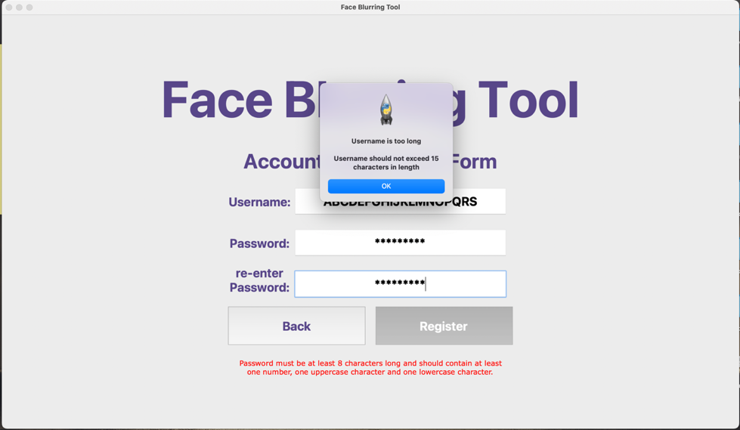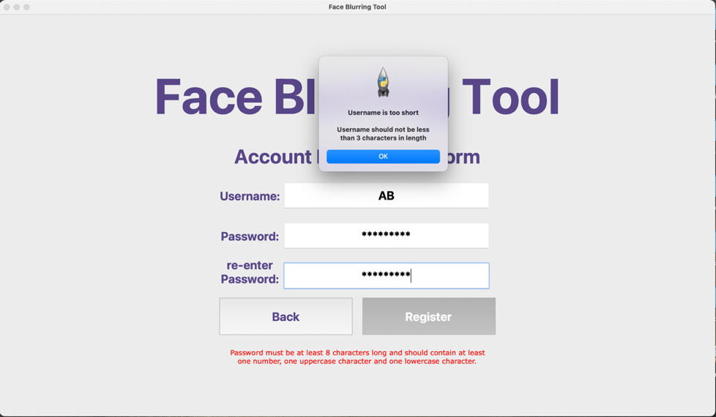**ALL ERROR MESSAGES THAT APPEAR:**

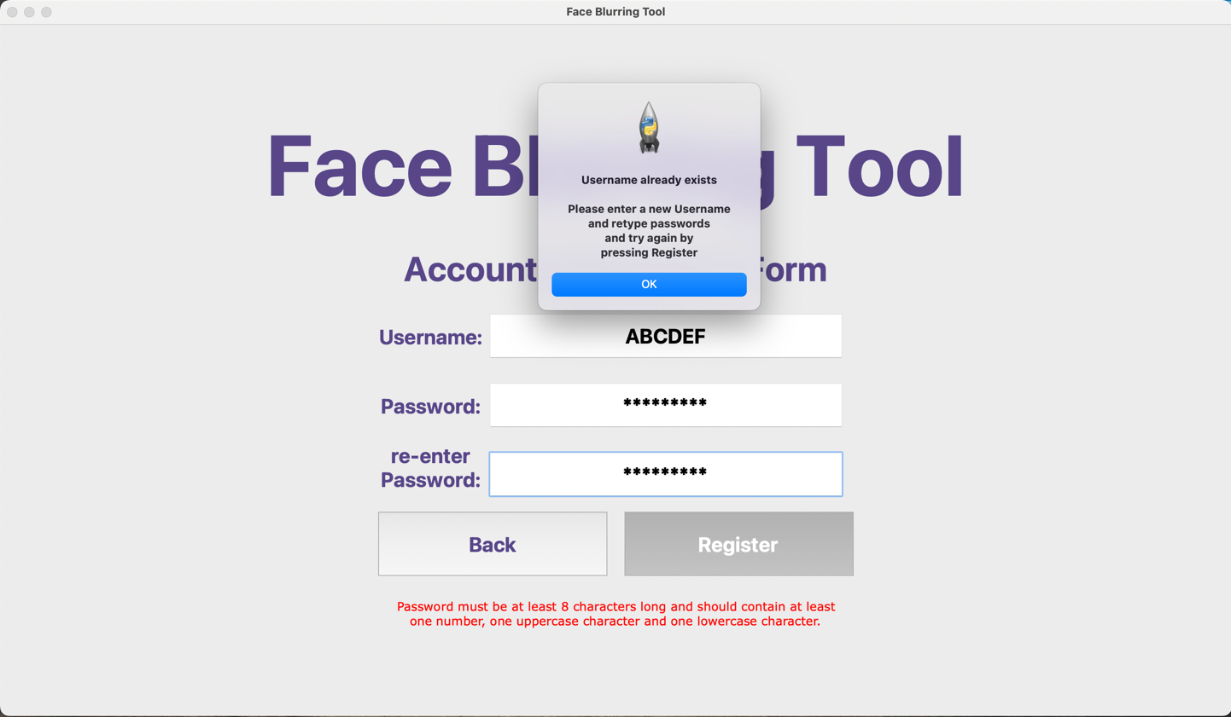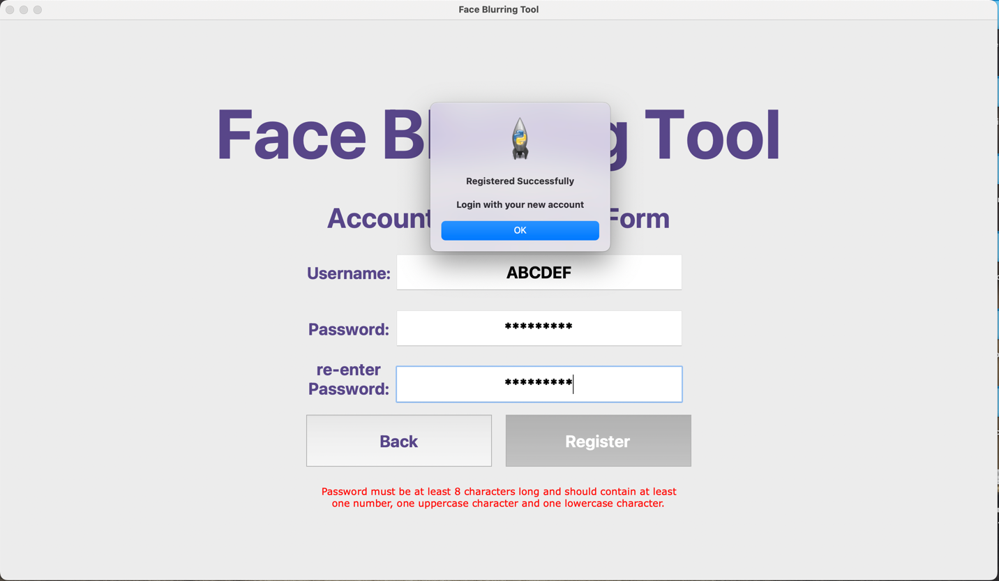

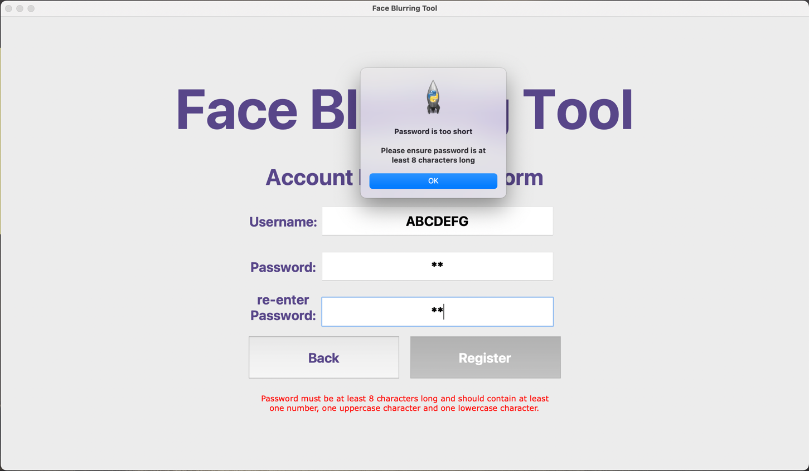

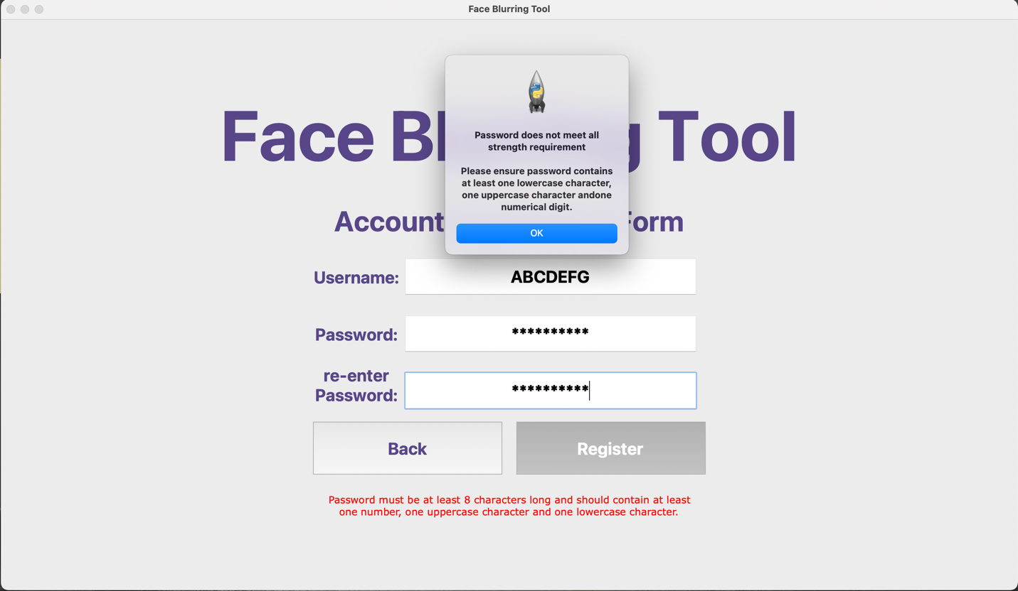

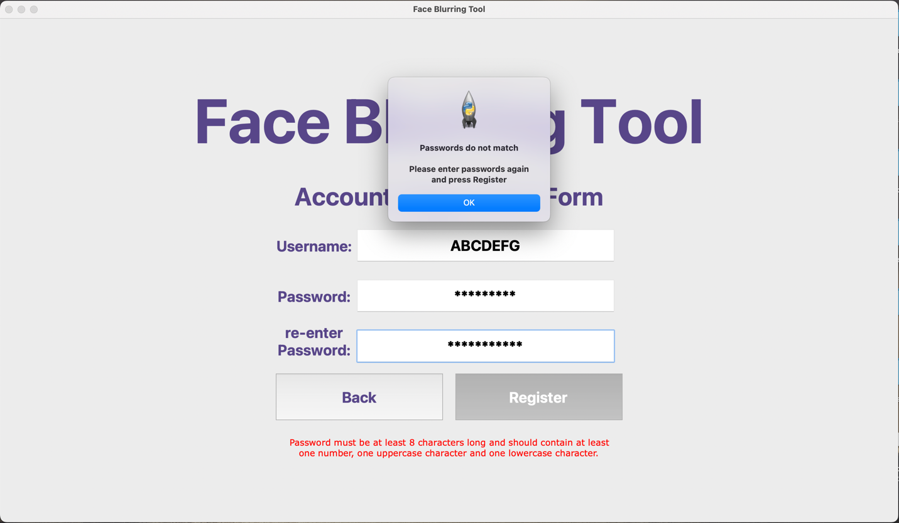

## **User Login testing:**

|  |  |  |  |  |  |
| --- | --- | --- | --- | --- | --- |
| Test Number | Test | Description | Expected Outcome | Actual Outcome | Comments |
| 1 | Wrong Username entered | If the wrong login details are entered user shouldn’t be given access | Error message should appear saying incorrect login details | As expected, | Not needed. |
| 2a) | Correct username with wrong password | If the wrong login details are entered user shouldn’t be given access | Error message should appear saying that login details are wrong | Error message appears when password is wrong, however user is granted access if no password is entered | Test was done during creation of login system another test will be done at the end. |
| 2b) | Correct username with wrong password | If the wrong login details are entered user shouldn’t be given access | Error message should appear saying that login details are wrong | As expected, | Previous error was fixed by fixing the database login system check, one of the if statements checking password had a logical error. |
| 3 | Correct username and password | User should be logged in successfully | Main menu screen should appear | As expected, | Not needed |

**ALL ERROR MESSAGES THAT APPEAR:**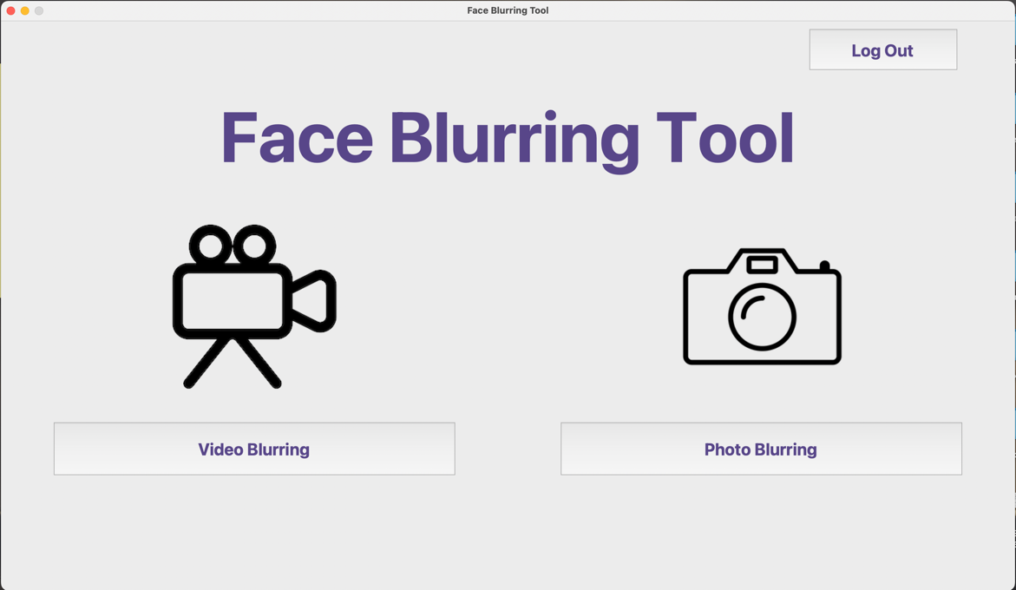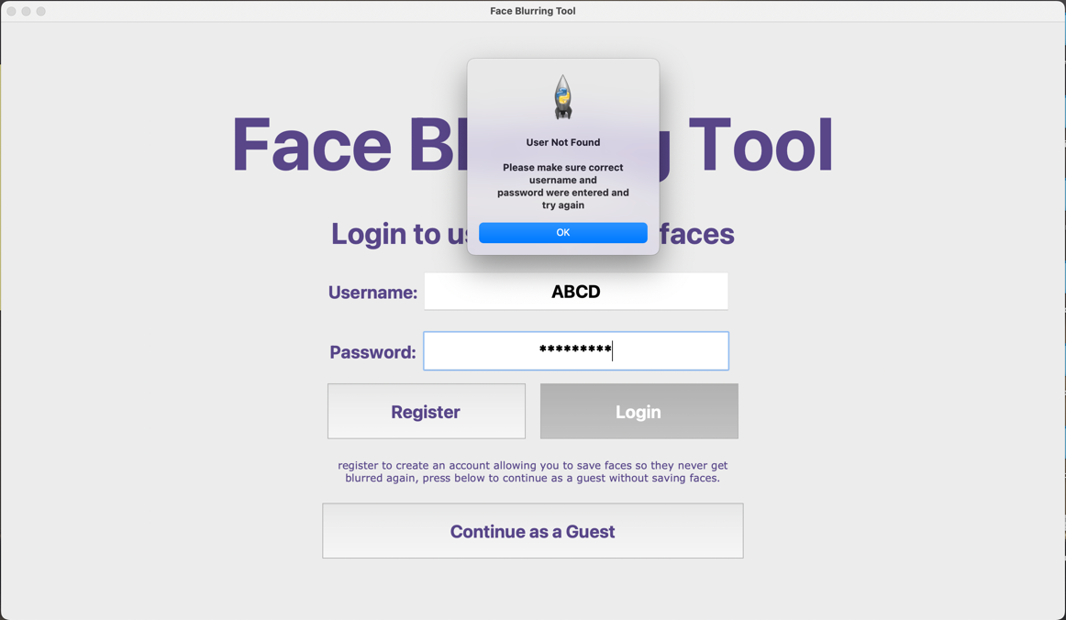

Correct username and password results in main menu opening and Users UserID being saved.

Test for both wrong username an wrong password

## **Hash algorithm testing**

Website used for Hashing SHA256 comparison:

https://emn178.github.io/online-tools/sha256.html

1a) testing a normal string

|  |  |
| --- | --- |
| Plain text | hello |
| SHA256 hashed text using website | 2cf24dba5fb0a30e26e83b2ac5b9e29e1b161e5c1fa7425e73043362938b9824 |
| SHA256 hashed text with my algorithm | 3f7e3436541b209e4ab50f5df185439b844c1d0d3f73fd84e5f9006258ef9aa |
| comment | Test was taken during programming of the SHA256 algorithm, output is different, although this might seem like no problem, this may result in duplicate outputs for different strings so it must be fixed. |

1b) testing a normal string

|  |  |
| --- | --- |
| Plain text | hello |
| SHA256 hashed text using website | 2cf24dba5fb0a30e26e83b2ac5b9e29e1b161e5c1fa7425e73043362938b9824 |
| SHA256 hashed text with my algorithm | 2cf24dba5fb0a30e26e83b2ac5b9e29e1b161e5c1fa7425e73043362938b9824 |
| comment | After fully reviewing my code, I found one binary shift right was done by 5 bits instead of 3 and I missed out a necessary logical AND operation in the function, now the outcome is the same |

2) testing a string containing numbers

|  |  |
| --- | --- |
| Plain text | 2132913081290408 |
| SHA256 hashed text using website | 5e87243ab2be9967c859b20ef699d75d686141fd6c85ba07cf1f09493acf668a |
| SHA256 hashed text with my algorithm | 5e87243ab2be9967c859b20ef699d75d686141fd6c85ba07cf1f09493acf668a |
| comment | Test completed with correct result. |

3) testing all types of characters

|  |  |
| --- | --- |
| Plain text | Askd#(@*KS203SLkfnsk#(*!)alsiLDK09 |
| SHA256 hashed text using website | 3a61206ef3b51a0ad009ccdf1b78cecbc78f309b7941809b178eb25e2d5ff1c2 |
| SHA256 hashed text with my algorithm | 3a61206ef3b51a0ad009ccdf1b78cecbc78f309b7941809b178eb25e2d5ff1c2 |
| comment | Test completed with correct result. |

4) testing if inputting a hashed value will create an error (previous output used as input)

|  |  |
| --- | --- |
| Plain text | 3a61206ef3b51a0ad009ccdf1b78cecbc78f309b7941809b178eb25e2d5ff1c2 |
| SHA256 hashed text using website | 257a04059e4eacc506d1883af96df12e60ef0349730c1d71c384b6d4ed73a9b7 |
| SHA256 hashed text with my algorithm | 257a04059e4eacc506d1883af96df12e60ef0349730c1d71c384b6d4ed73a9b7 |
| comment | Test completed with correct result a different hash is outputted, my algorithm output matches the one on the website |

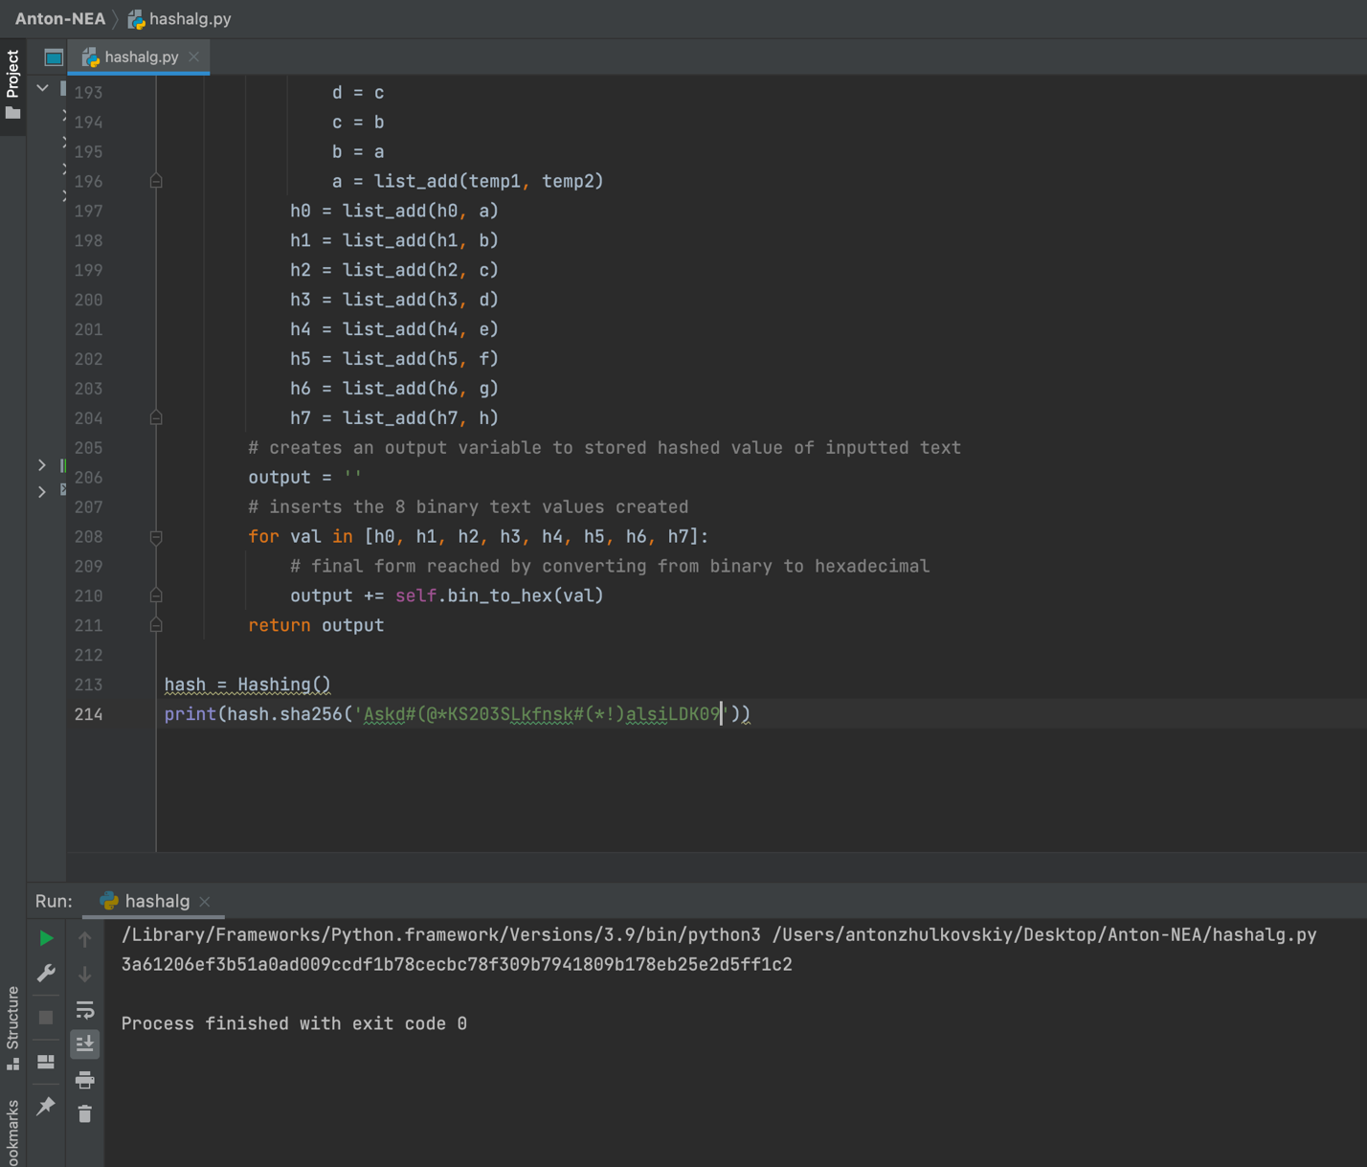

OUTPUT HASHED TEXT

INPUT PLAIN TEXT

## **Blurring images and videos test**

**Screen Shots of all test results can be seen under the table**

|  |  |  |  |  |
| --- | --- | --- | --- | --- |
| Test number | Test | Expected Output | Output | Comment |
| 1 | Blur image with single face | Image with only the face blurred beyond recognition | As expected, | Not needed. |
| 2a | Blur image with multiple faces | Image with all faces blurred beyond recognition | Blurring strength too weak face is visible | Test was taken during creation of blurring algorithm. |
| 2b | Blur image with multiple faces | Image with all faces blurred beyond recognition | As expected, | I rewrote the blurring algorithm to allow blurring strength to be stronger without impacting time too much. |
| 3 | Blur image with multiple faces and ignore one face | Image with all faces blurred except for the one uploaded in the ignore face section | As expected, | Not needed. |
| 4a | Blur image with multiple faces with several faces ignored in blurring effect | Image with all faces blurred except for the ones in the ignore file. | Only first face being ignored. | Test was done whilst writing algorithm, will be tested again after completion |
| 4b | Blur image with multiple faces with several faces ignored in blurring effect | Image with all faces blurred except for the ones in the ignore file. | As expected, | Previously, the program failed to access all ignore face images and only accessed the first one, now the problem is fixed. |
| 5 | Video blurred with different faces throughout | Same video with the faces blurred in all frames. | As expected, | Not needed. |
| 6 | Video blurred with one face ignored in blurring | Same video with one face blurred and one face not blurred. | As expected, | Not needed. |

1. 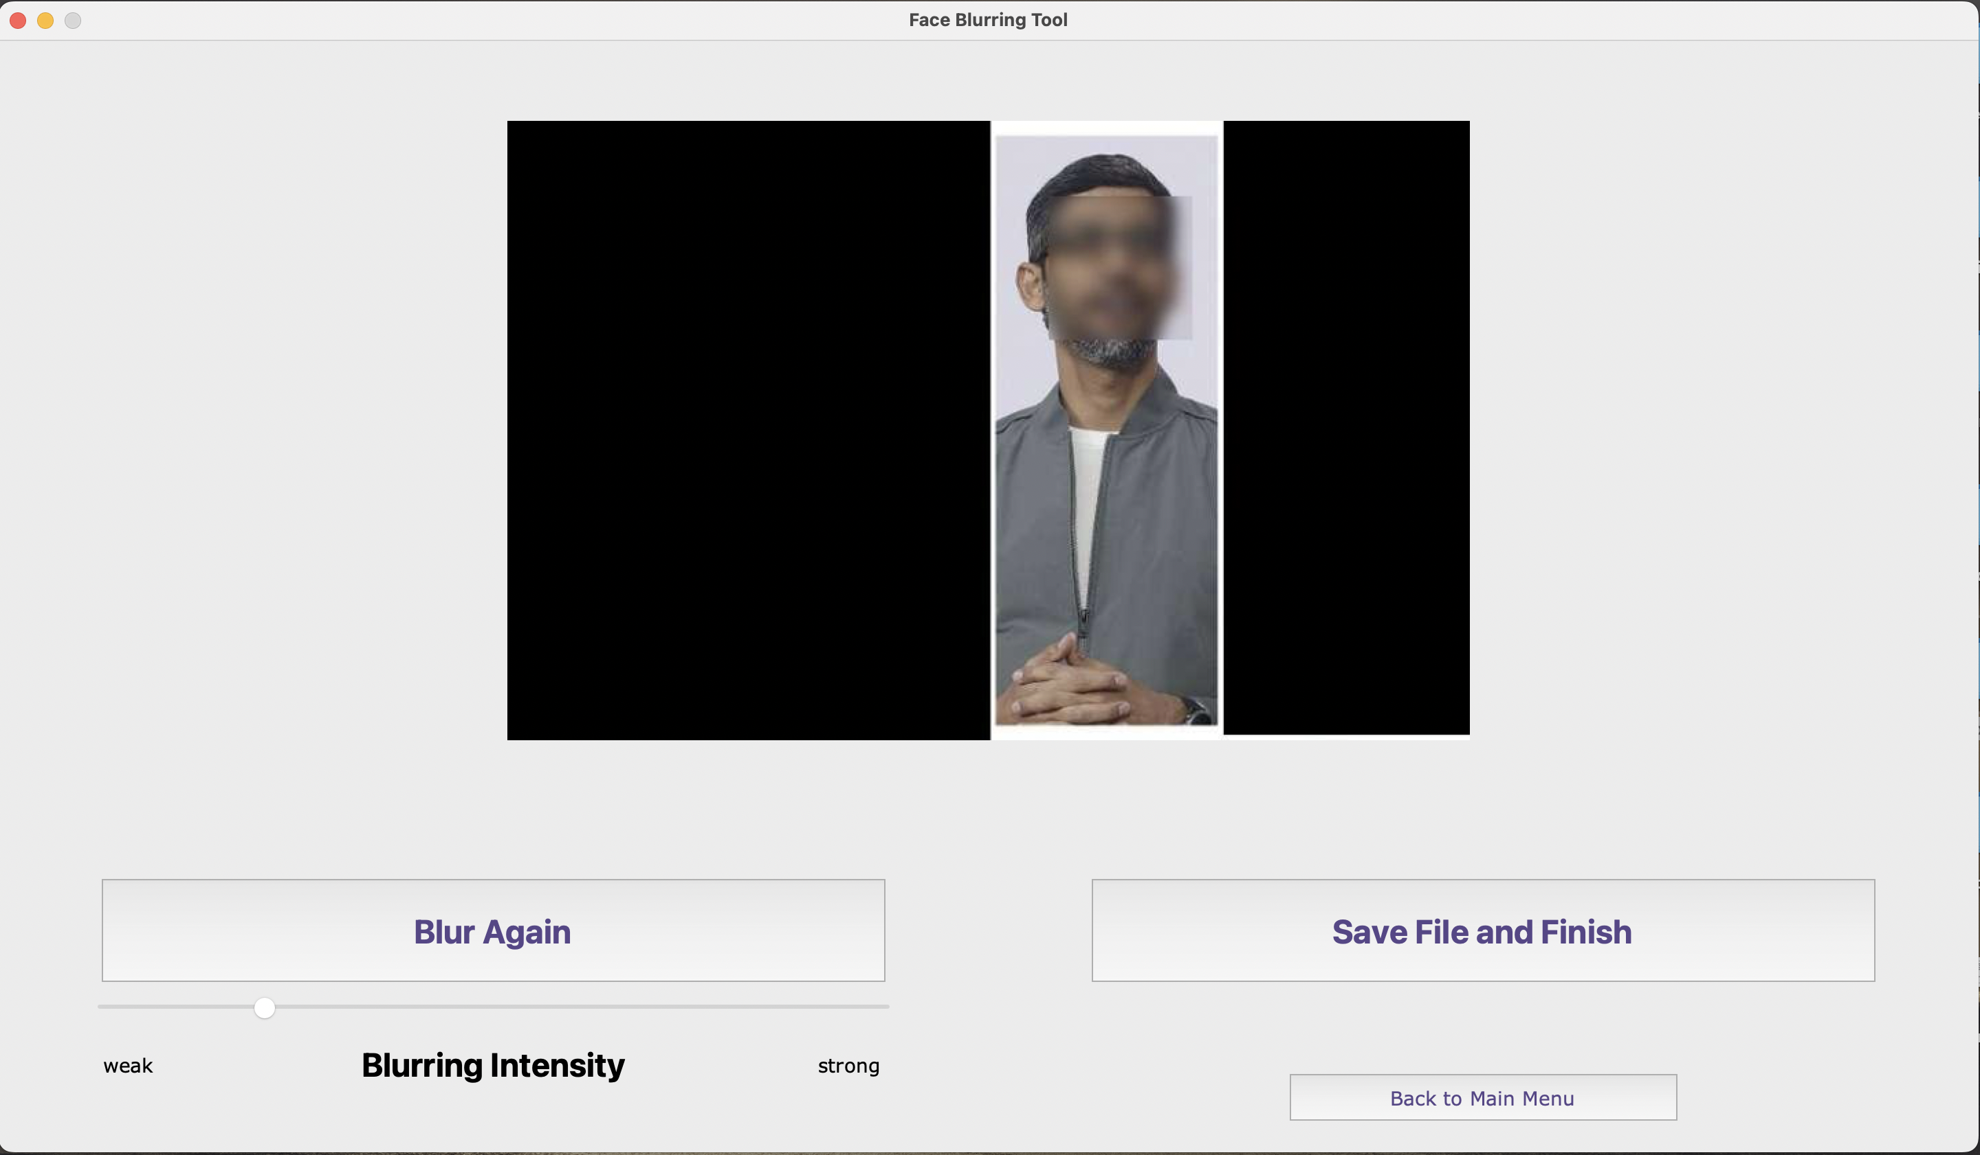successful

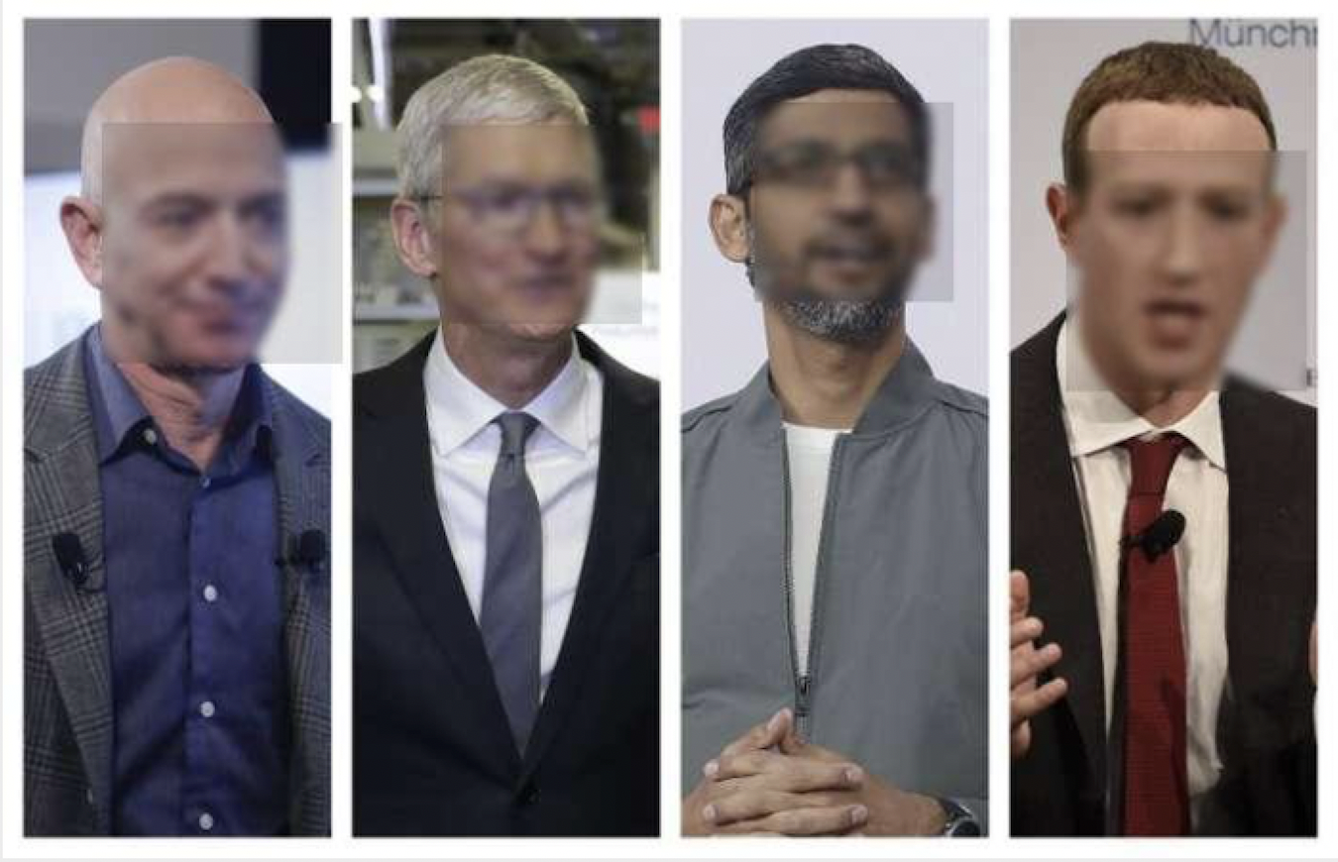2a) failed

2b) problem fixed, successful

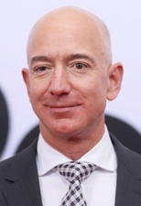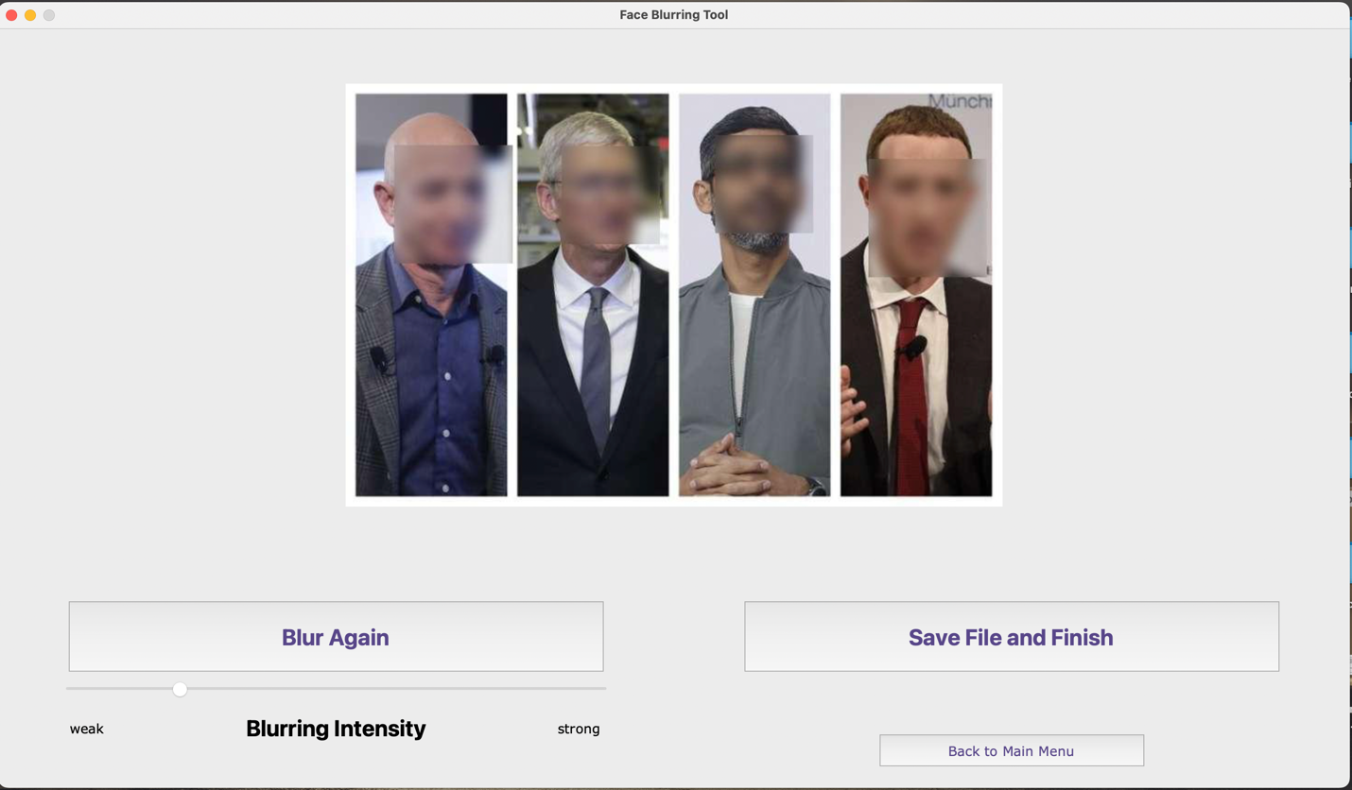

Image uploaded to be ignored

1. Successful

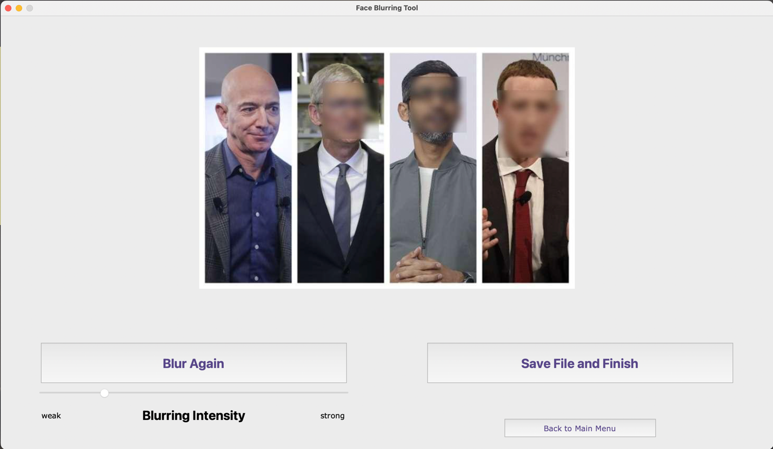

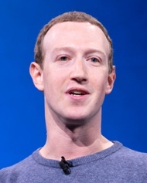

1. successful

Image uploaded to be ignored

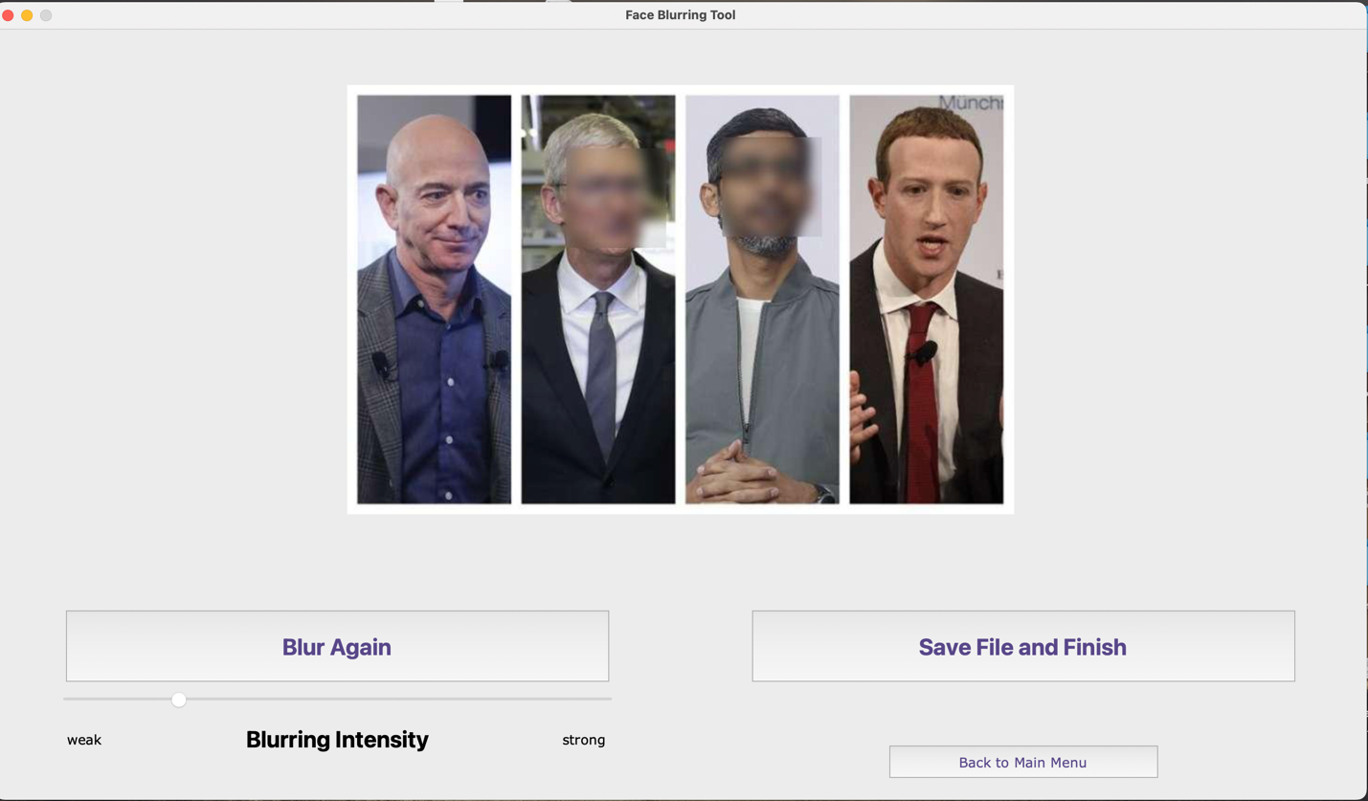

5)successful

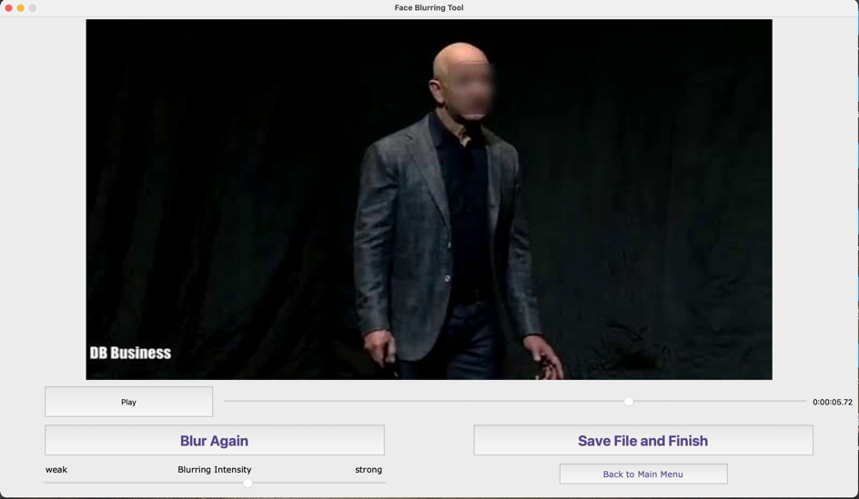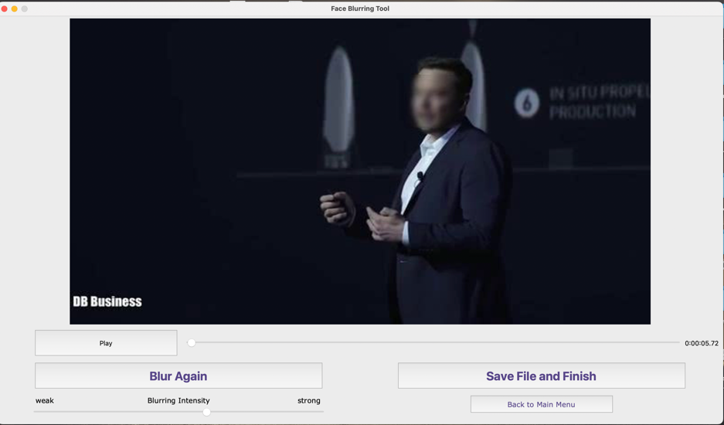

1. 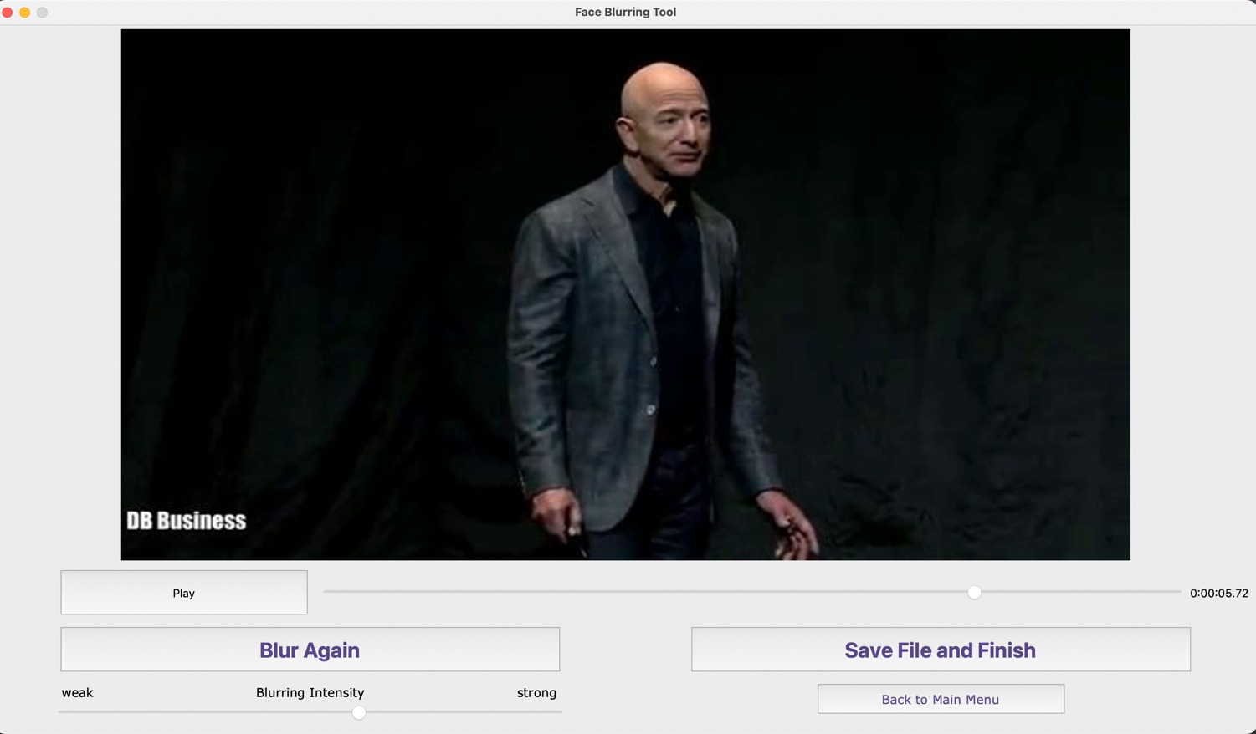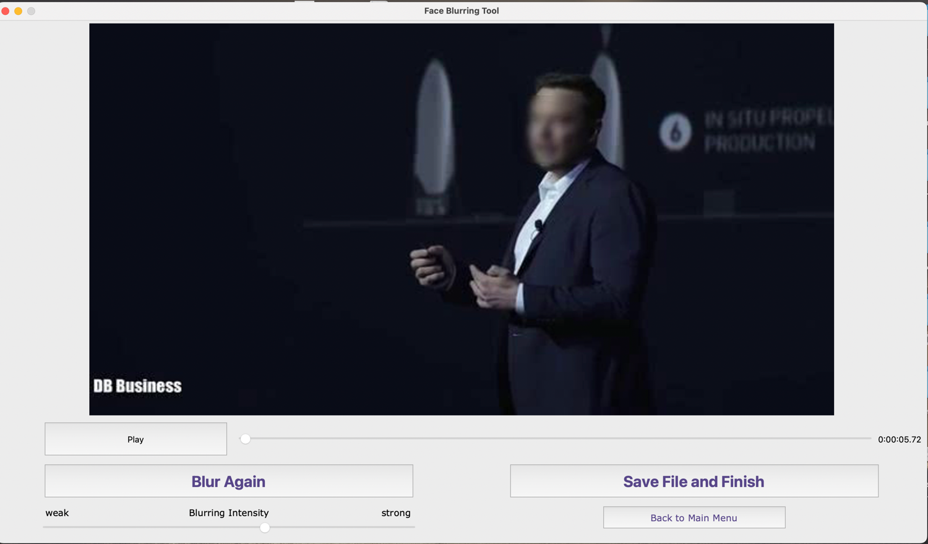successful

Image uploaded to be ignored

## **Database data storing testing**

|  |  |  |  |
| --- | --- | --- | --- |
| Test number | Test | Expected outcome | Outcome |
| 1 | Create user login | Stores hashed username and password in tblUsers, with default video and photo setting | As expected, |
| 2 | Change intensity when blurring photo | tblUsers users PhotoSetting should change to new intensity | As expected, |
| 3 | User login after changing intensity in previous session | Last used intensity should automatically be set | As expected, |
| 4 | User checks save for future checkbox when uploading face image in photo section | Should save the face image to database in tblPhoto. | As expected, |

1. successful

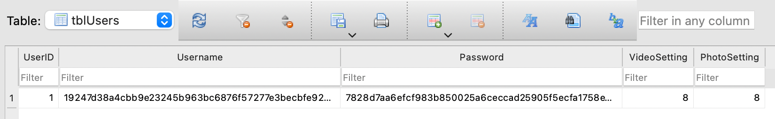

1. successful

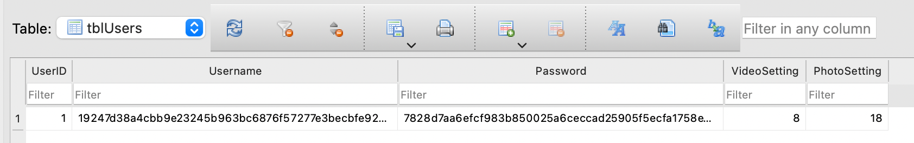

1. successful

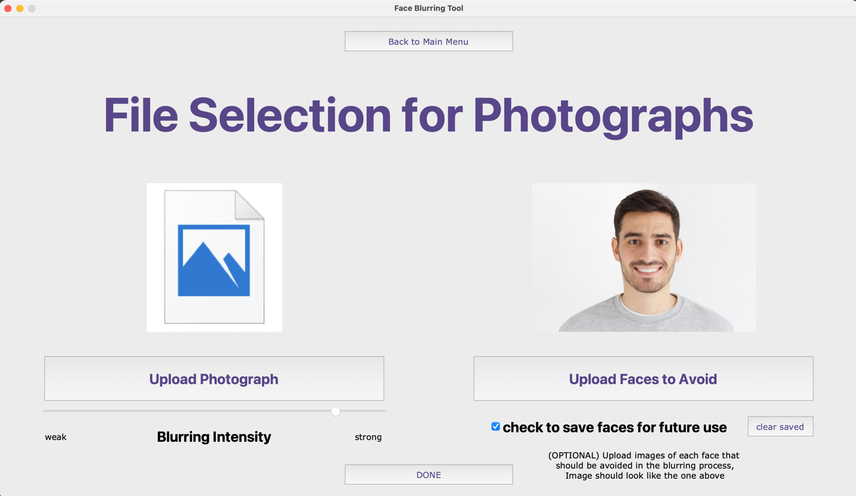

1. successful

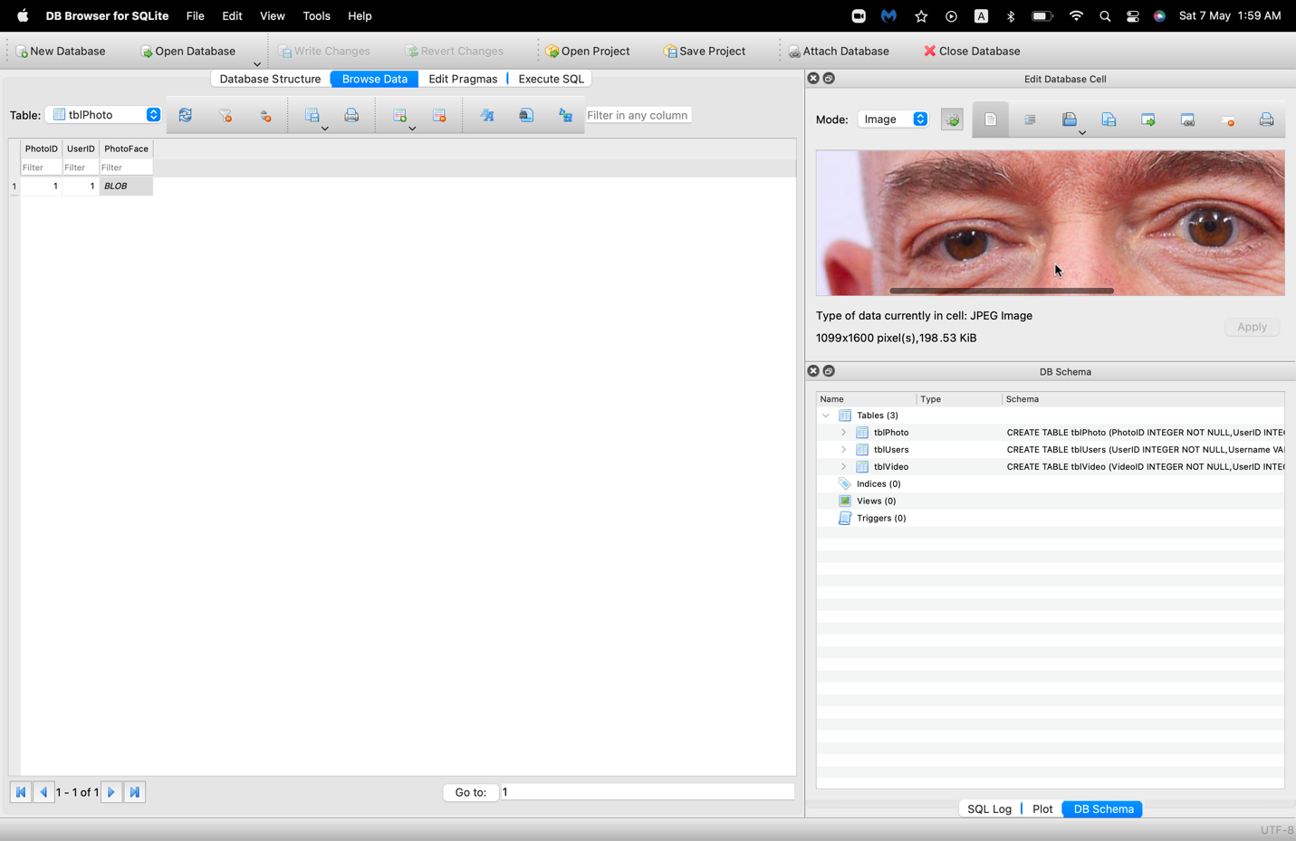

# **Evaluation:**

## **Objective table:**

|  |
| --- |
| FULLY ACHIEVED TARGET |
| ALMOST ACHIEVED TARGET |
| TARGET NOT ACHIEVED |

|  |  |
| --- | --- |
| **Original objective** | **What I have achieved** |
| 1. The system has to have two sections:    1. Photographs    2. Videos | A system which has both photograph and video blurring sections |
| 1. A system has to be set in place for user to Input their photograph or video | A file searching popup appears in the GUI for user to select their file (photo or video). |
| 1. User should be able to input pictures of faces they would like avoided in the blurring process | A file searching popup appears when avoid faces button is pressed which allows several faces to be uploaded to avoid in blurring process |
| 1. System must be put into place to adjust the strength of the blur. | A drag bar is shown in the GUI which allows the user to change blurring strength by adjusting the size of the gaussian kernel. |
| 1. Input section must work quickly and must be simple to understand | Both video and photo inputs are taken in instantly as well as settings being applied and user logins. |
| 1. Every face in video/photo must be blurred (except the inputted faces) | Both video and photo blurring successfully blur all faces apart from the faces uploaded to the avoid section. |
| 1. For videos, blurring must be done frame by frame for accurate facial tracking | Videos are broken down into frames, all faces in each frame are blurred separately, then the video is reconstructed with all the faces blurred. |
| 1. Photo blurring process should be almost instant | At highest blurring strength photograph blurring only takes a couple seconds, at lower strengths it is almost instant. |
| 1. Video blurring process should be quick | Short videos can be blurred in a short period of time, however longer videos with many faces can take some time to blur. |
| 1. The user should be given a preview of what the blurred video/photo will look like | After blurring, a new frame appears in the GUI showing the blurred image. For video blurring the frame appears allowing the user to play through the video with pausing and skipping available. |
| 1. User should be able to decide whether they are happy with the blur | There is an option to adjust blurring strength and re-blur the image or video in the preview frame. |
| 1. If not, blurring process must be restarted | SAME AS ABOVE. |
| 1. Once successful, video or photograph should be saved | A save button is shown in the final frame of the GUI, which opens the file explorer to allow the user to choose filename and save location to save the blurred photo or video. |
| 1. Output should be of the same file type as the user has inputted | Output will be of the same file type as the uploaded images, video input and output are only done in MP4 format. |
| 1. System must make it clear to user where final file will be saved, or user must be given the option of choosing file location. | User chooses their own output save location meaning it will be clear to them where the final photo or video will be |
| 1. Login system must be put into place for users to use their preferred blurring settings as well as access their saved faces | User login system is available with a username and a password. |
| 1. Fully normalized database should be created to store saved photographs of faces if user choses to save them user login details should also be stored | A three table third normal form database is available which stores all settings, login details and faces to be ignored in blurring for each user. |
| 1. User login details have to be stored encrypted or hashed. | I made a SHA256 algorithm to hash all usernames and passwords to ensure their full security even if someone views the database. |

Overall, I believe that my project has achieved pretty much all my targets and is able to blur images, videos and ignore faces that are uploaded to be ignored. There is a working login and registration system with a quick and secure hashing algorithm. However, whilst doing the project I came across ideas that I did not originally have in mind which I could have implemented such as a user recovery system using emails and maybe allowing the software to be run on a website rather than locally for the convenience of users.

**User Feedback and testing google form responses**

(Sunmarke Head of Marketing)

(Sunmarke Student)

(Sunmarke School Teacher)

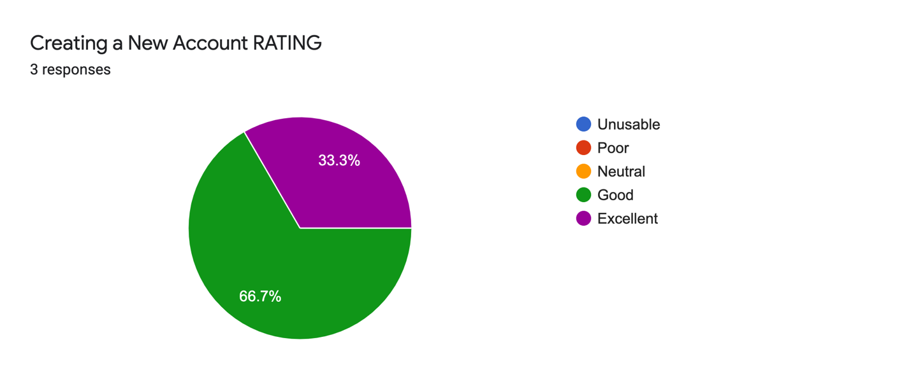

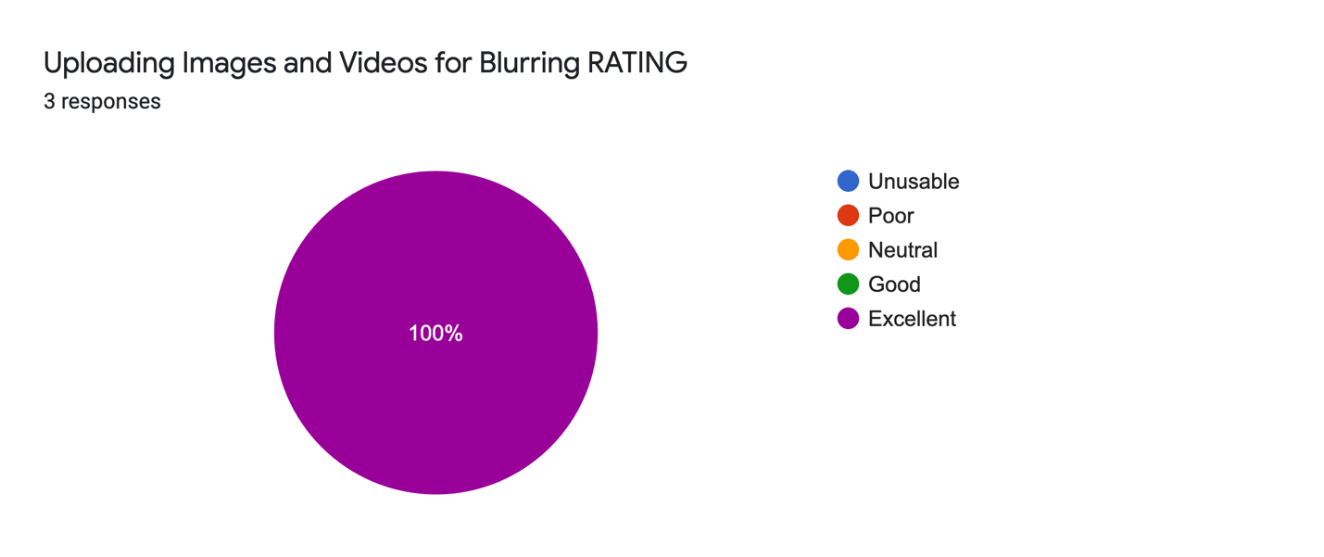

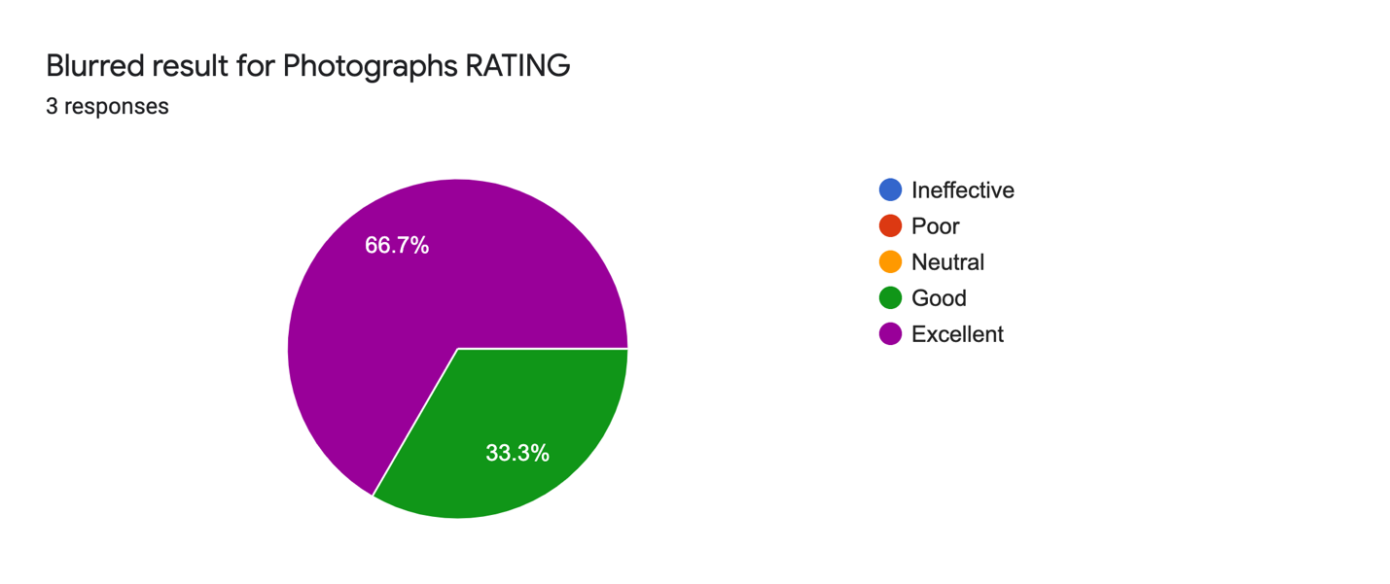

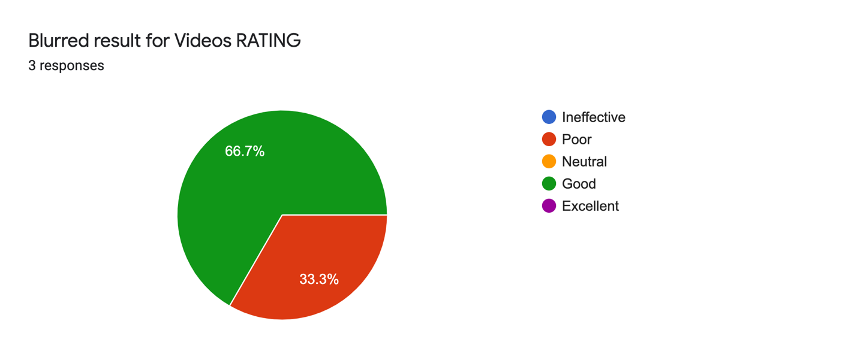

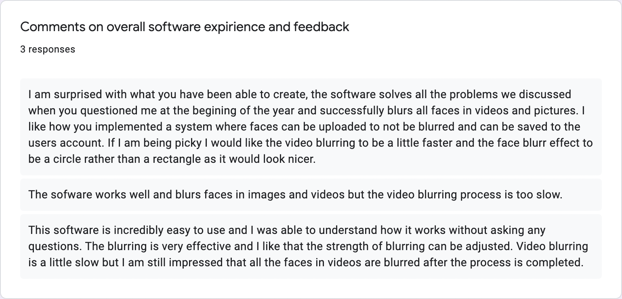

(Sunmarke Head of Marketing)

(Sunmarke School Teacher)

(Sunmarke Student)

**MY FEEDBACK RESPOSE:**

From all the feedback I have heard I have concluded that users are happy with how to GUI looks and works as well as image blurring results and process. I need to improve on the video blurring speeds and possibly implement an option to change blurred shape to be round and smoother looking. Also, some users have said they think the account should have email recovery incase user forgets their password.

## **Conclusive thoughts:**

**MoSCoW approach (must have, should have, could have and would have)**

**MUST HAVE:**

I have created a working gaussian blurring algorithm with a graphics user interface which allows for faces in both photographs and videos to be blurred by users. There is a working registration and login system which allows users to save their uploaded face images to a database preventing these faces from ever getting blurred when the user is logged in. Usernames and passwords of users are securely stored on the database after they go through the SHA256 hashing algorithm that I programmed. Users can also adjust their blurring intensity for both videos and photographs and if they are logged in, their last used blurring intensity is saved to the database and will be preset next time they login or try and blur another image or video. Although I have achieved most of my targets, there are many improvements I could implement if I were to do a similar project again.

**SHOULD HAVE:**

Since I used python, this significantly hindered the speed of blurring due to python using an interpreter to execute code line-by-line making recursive functions slow. In the current system I chose to use MATLAB to reduce speed of blurring importing my code from MATLAB to python using the inbuilt engine with the gaussian blur calculations fully done and applied to images on MATLAB. This required me to learn how to use MATLAB and implement it with my already made python code.

**WOULD HAVE:**

If I ever did a project with image blurring again, I would use a lower-level language which executes using a compiler such as C++ or C# as those would allow for the whole program to be coded on one language with much faster execution times. Second, my program often has difficulties blurring faces which are from side view or very large angle to the camera so if I did a facial detection algorithm again, I would consider implementing the OpenCV face locating algorithm with several Haarcascade files to allow the image detection algorithm to detect any angle of the face.

**COULD HAVE:**

Another thing I would consider if I were to do a facial blurring tool is to try and implement the system into a webpage for the convenience to users as users wouldn’t need to download or setup anything and simply upload their images online to be blurred. Also, I would allow users to link an email to their account to allow them to reset their passwords through their email if they forgot their password.